# 1. Introduce Spring

## 1.1 About this book

## 1.2 What is Spring?

-Spring: a lightweight framework for building Java applications.

+You can use Spring to build any application in Java

+lightweight isn’t related to number of classes or the size of distribution, it’s the principle of Spring philosophy: minimal impact: you have to make few changes to app to gain benefits

### 1.2.1 Evolution of Spring Framework

(See in book)

### 1.2.2 Spring Projects

spring.io/projects

(See in book)

## 1.3 Inverting Control or Injecting Dependencies

-The core of Spring Framework is based on the principle of **inversion of control (IoC)**: a technique that externalizes the creation and management of component dependencies. The action performed by any program is the result of interaction between its interdependent components.

-**Dependency injection (DI)**: a concept that describes how dependent objects are connected at runtime by an external party.

-Object A needs an object of type B to perform its functions -> A depends on B. The 3 ways these 2 objects get to interact:

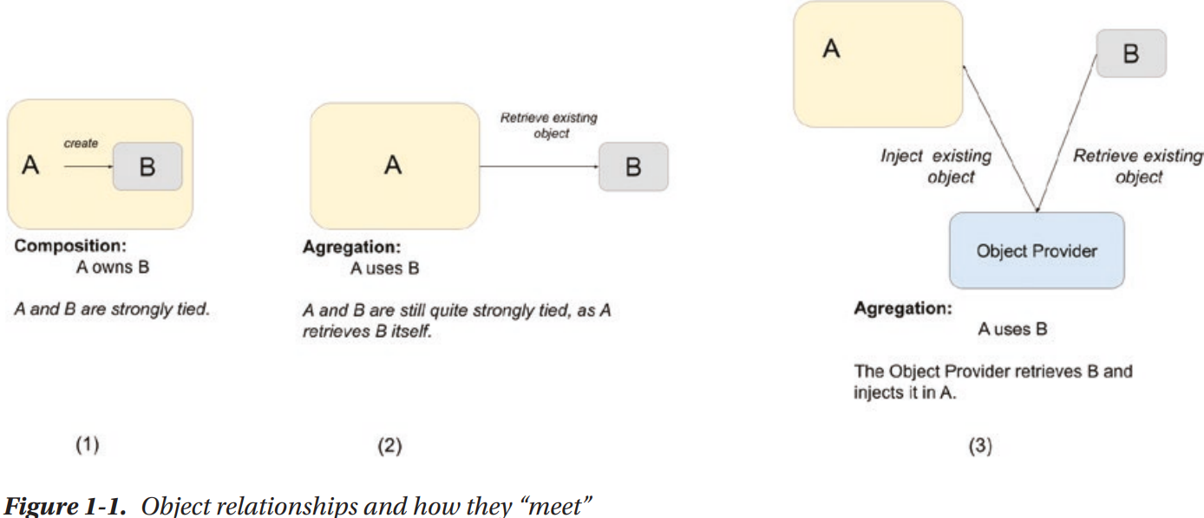

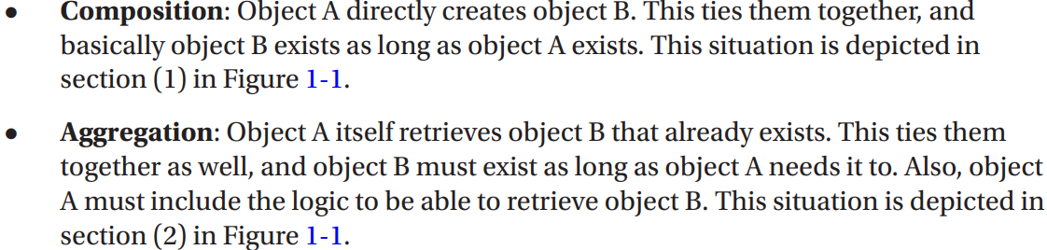



-**Inversion of control**: a design principle in which generic components are used to control the execution of problem-specific code, as in retrieving dependencies. Spring is a **dependency handler** used to perform DI, it was designed following IoC principle

-Spring’s DI implementation based on 2 core Java concepts: JavaBeans (POJOs-plan old Java objects) and interfaces.

-You can define dependency configuration in different ways: XML, annotation, Java configuration classes, Groovy-based configuration

-JavaBeans (POJOs) provides a standard mechanism for creating Java resources that are configurable in a number of was (constructors, setter methods). Any Spring-managed resource is bean.

-Interfaces and DI are technologies that are mutually beneficial. Designing and coding application to interfaces makes for a flexible application, but the complexity of wiring together is high. Using DI, you reduce the code you need to use an interface-based design in app.

+The use of interfaces allows dynamic proxies (Proxy pattern) to provide AOP.

-In context of DI, Spring acts like a container: provide instances of your application classes with all dependencies they need. Using Spring for DI follows JavaBeans naming conventions within your classes

### 1.3.1 Evolution of Dependency Injection

(See in books)

### 1.3.2 Beyond Dependency Injection

(See in books)

## 1.4 The Spring Community

# 2. Getting Started

## 2.1 Conventions

## 2.2 Who this book is for

## 2.3 What you need for this book

## 2.4 Prepare development environment

## 2.5 Understand Spring Packaging

-Spring packaging is modular: it allows to pick and choose which components you want to use in your application and to include only those components when you are distributing your app.

-Spring modules are JAR files that package the required code for that module.

-Spring Framework 6.0 comes with 22 modules. These name like: spring-<>-6.0.0.jar

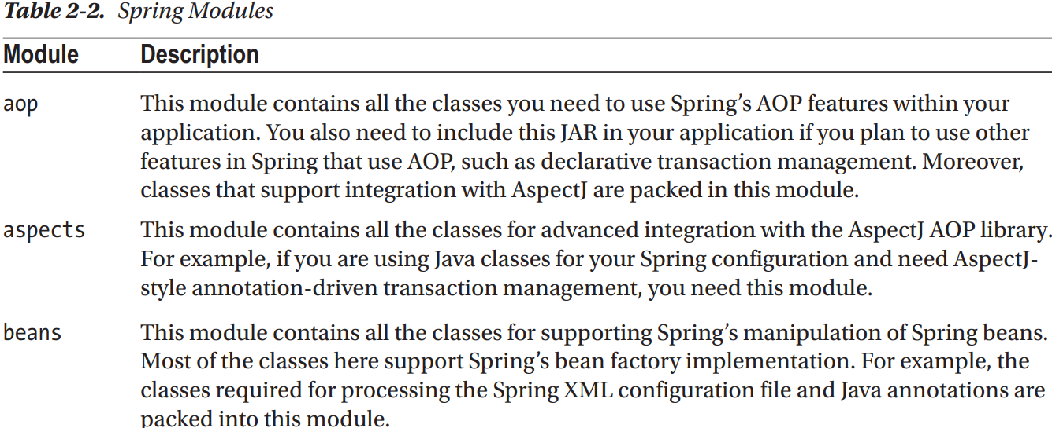

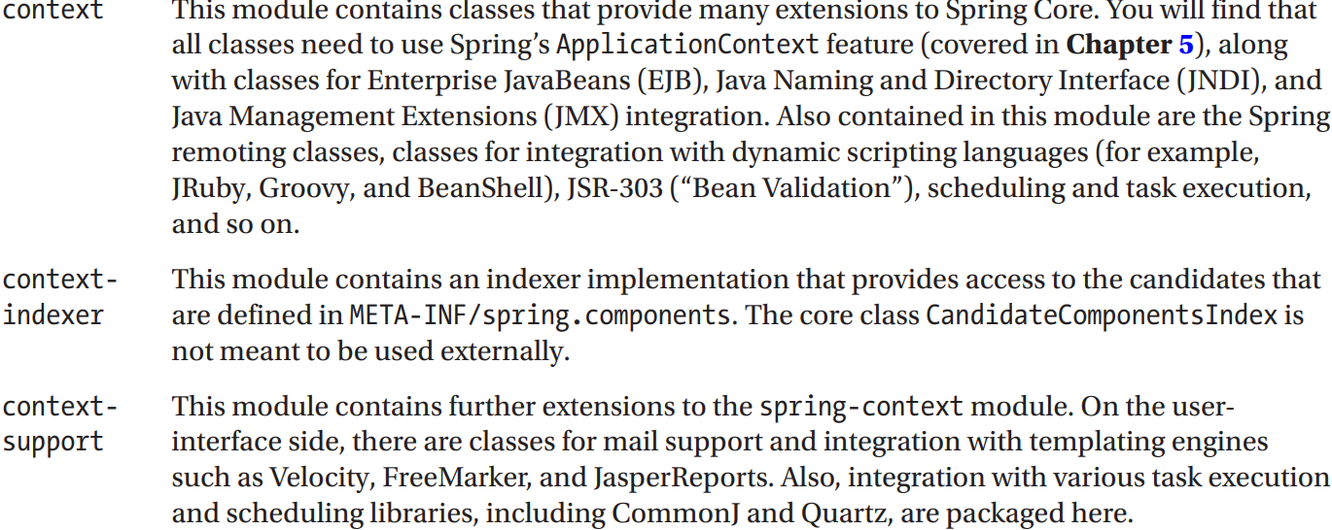

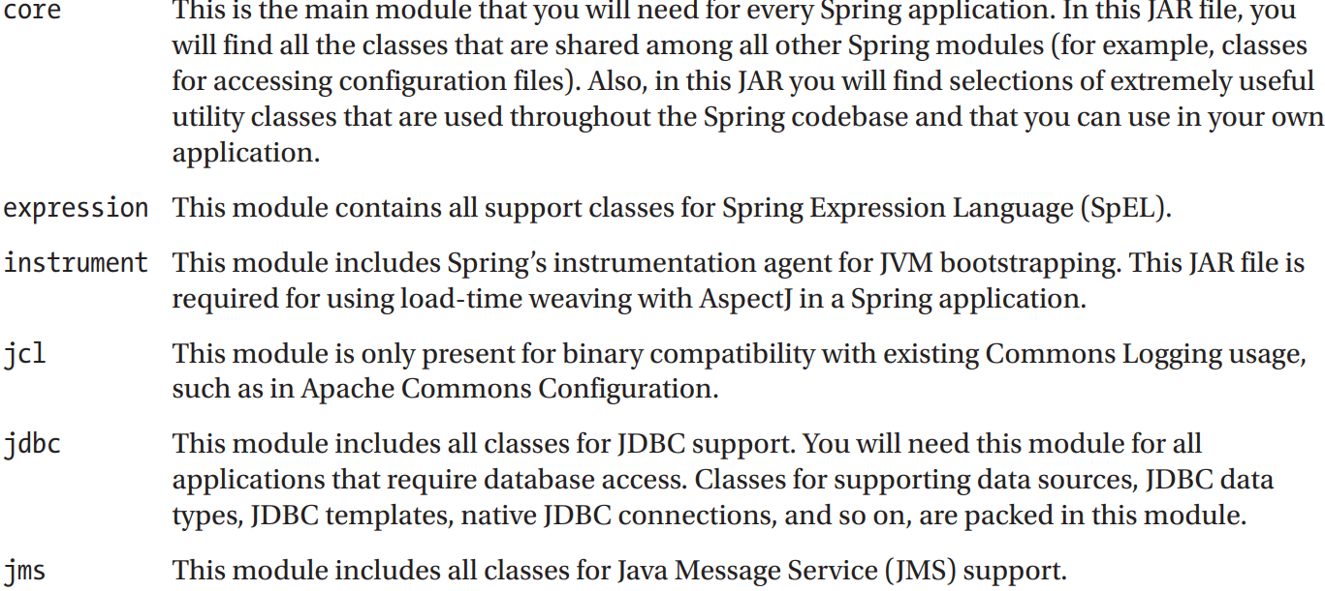

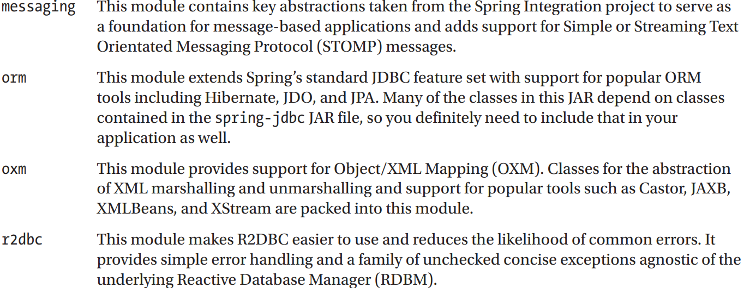

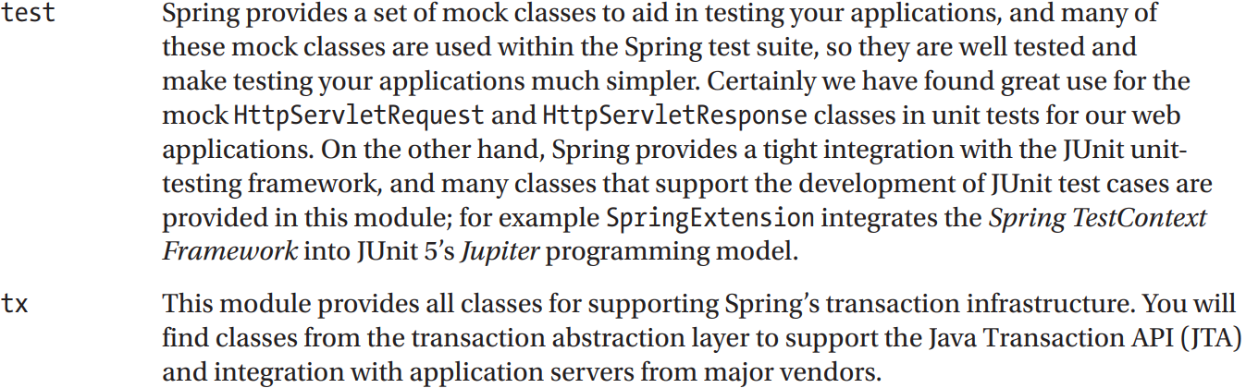

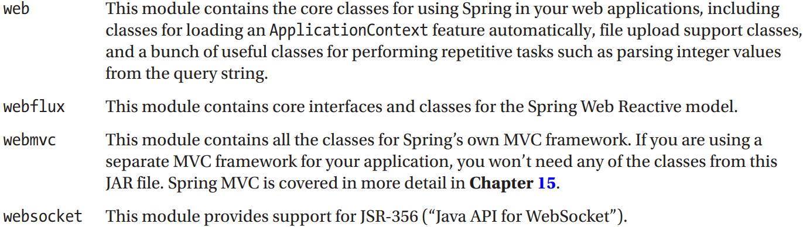

-If you sing Spring Boot, the appropriate set of Spring dependencies are configured depending on Spring Boot starter dependencies used. There are more than 30 of them

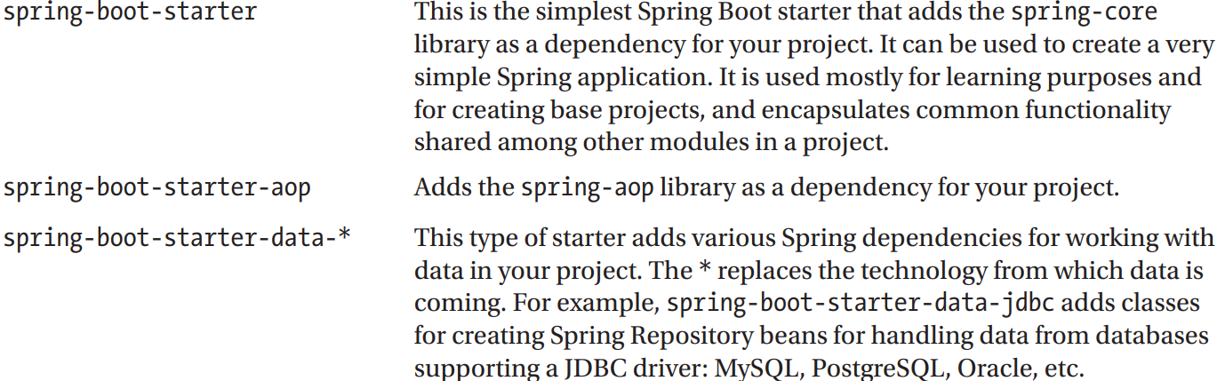

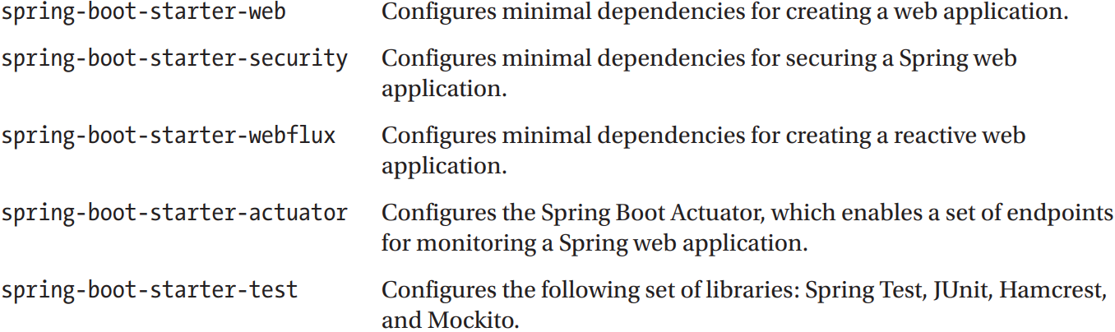

## 2.6 Choose Modules for your application

-Without dependency management tool (Maven, Gradle), choosing which modules to use in application may be tricky.

### 2.6.1 Access Spring Modules on Maven Repository

### 2.6.2 Access Spring Modules Using Gradle

-Gradle is a powerful build tool use Groovy. Starting with version 4.x, Spring team has switched to using Gradle for configuration.

-The default name of Gradle configuration file for project is build.gradle.

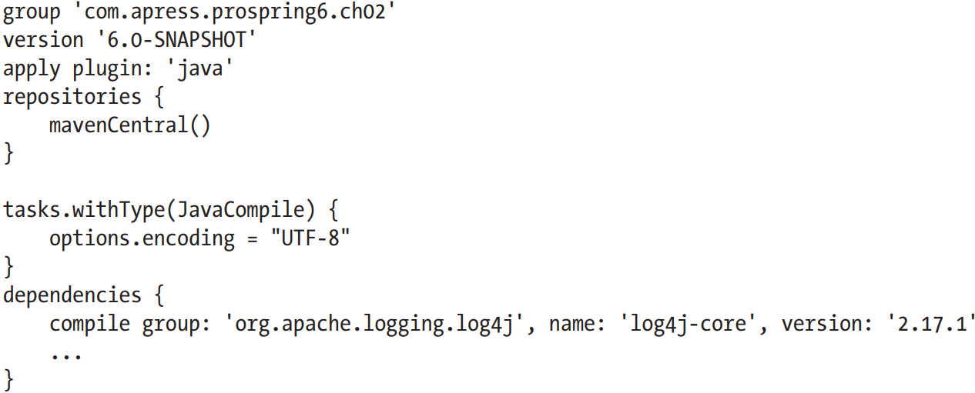

### 2.6.3 Use Spring Boot Dependency Management

-You can use Spring Boot starter project as a parent project to provide your project with a minimal set of dependencies and default configuration.

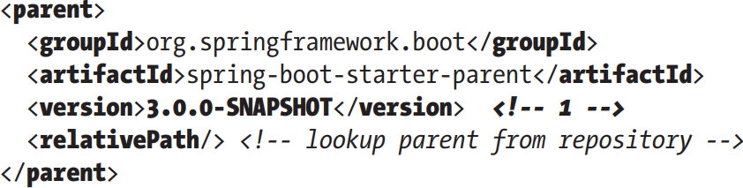

-<dependencyManagement>

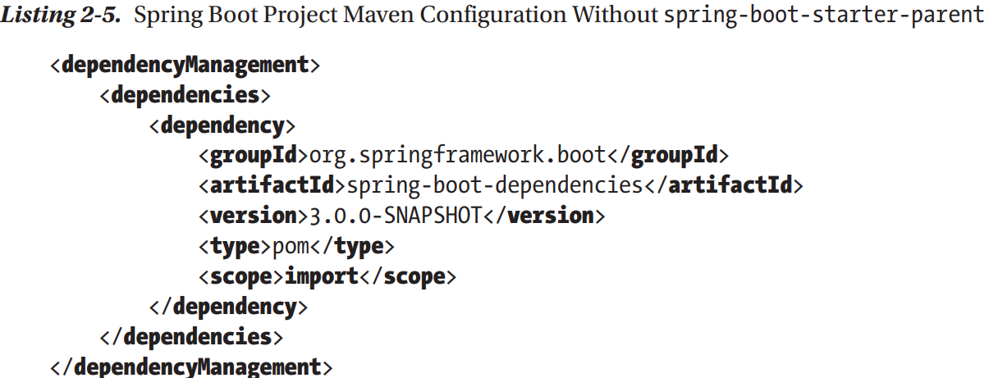

-Gradle Spring Boot

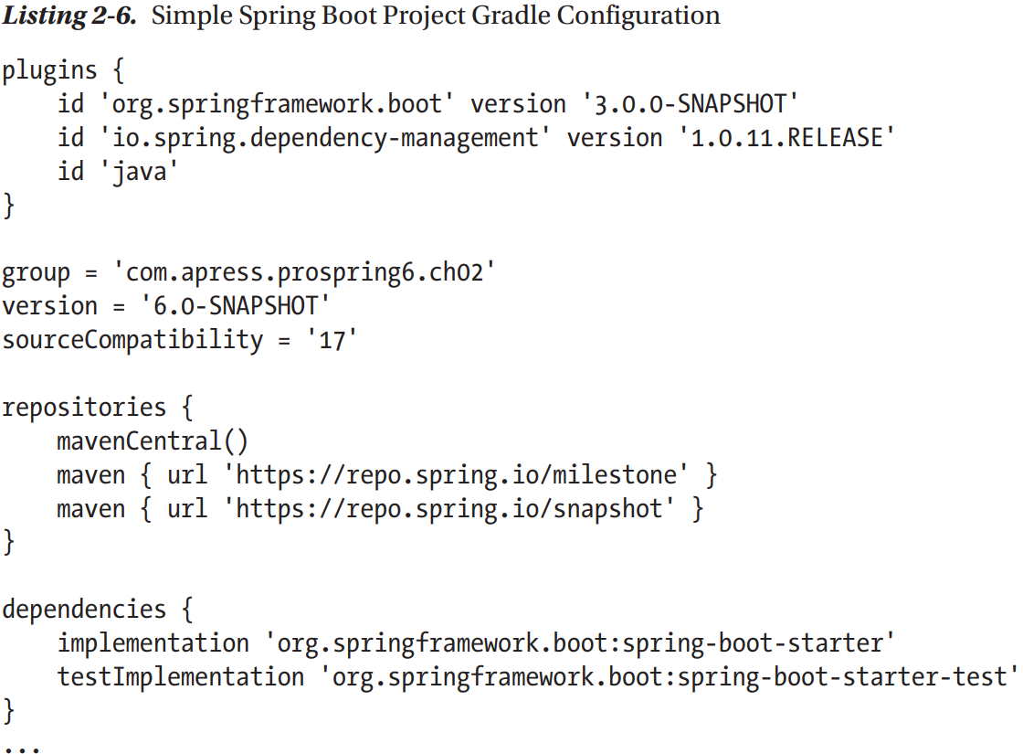

-In bigger projects, organized in multiple modules, configuration can create configuration templates that can be reused in modules.

## 2.7 Use Spring Documentation

docs.spring.io/spring-framework/docs/current/javadoc-api/

docs.spring.io/spring-framework/reference/

## 2.8 Putting a Spring into Hello World

### 2.8.1 Build sample

-Refactor the rendering and message retrieval login into separate components. And we should have these components implement interfaces and define interdependencies between components and launcher using these interfaces.

-Refactor message retrieval logic

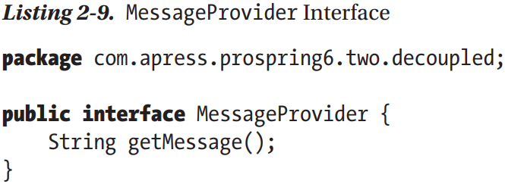

-Interface for render message

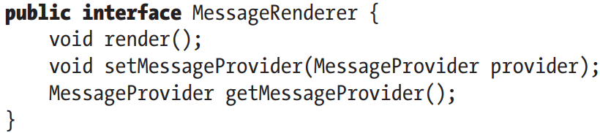

-MessageProvider is a dependency of MessageRenderer

-Implementations

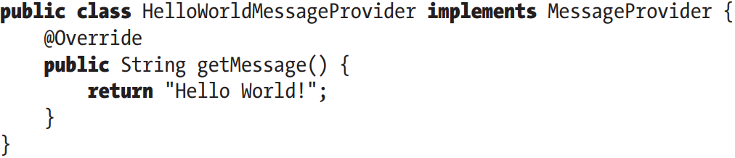

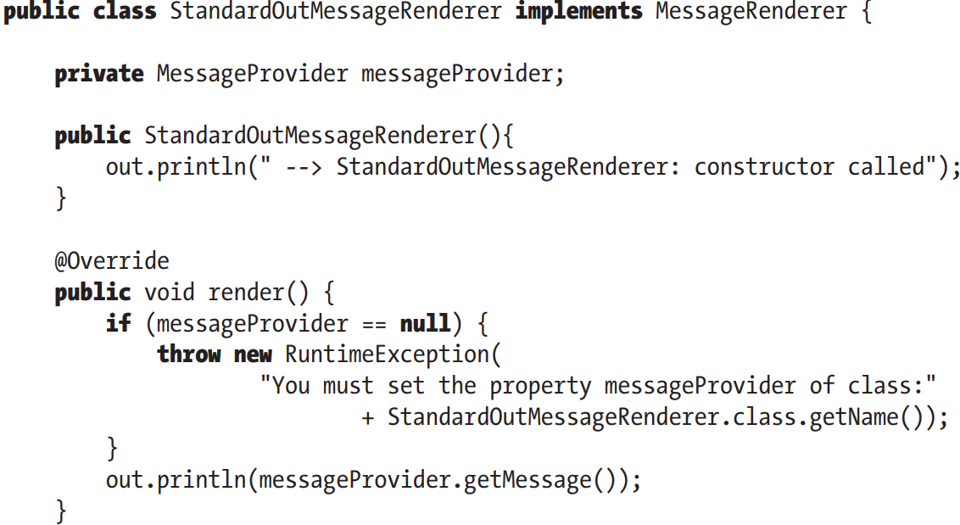

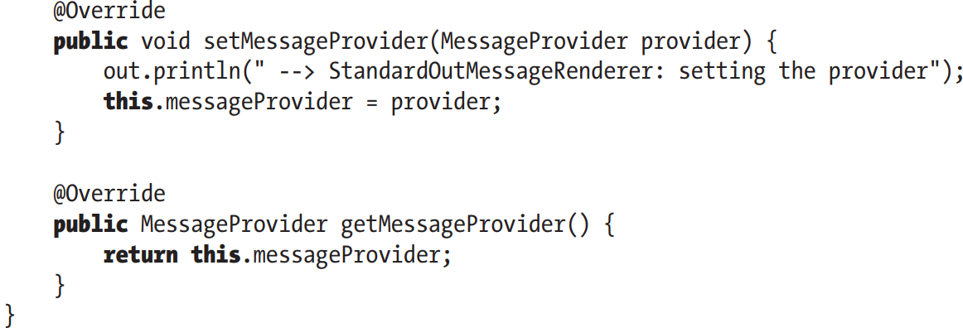

-Rewrite the main()

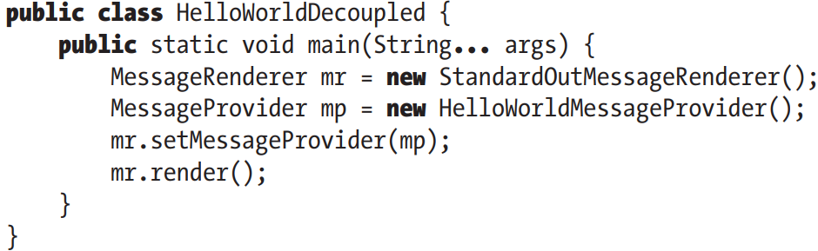

-Abstract schema:

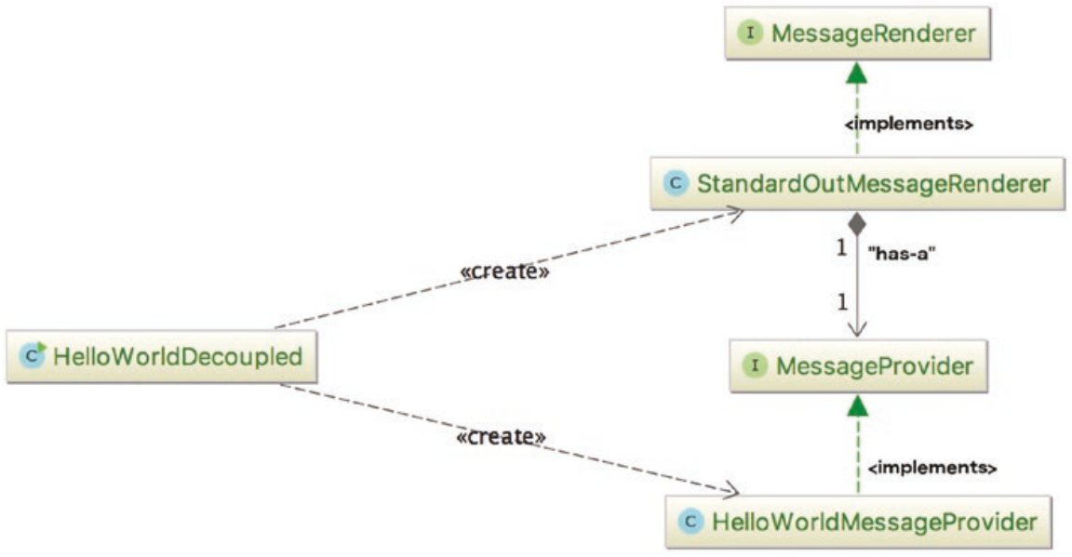

-Changing the implementation of interfaces means a change to code. The manual one is to create a simple factory class reading implementations class name from a property file and instantiates them.

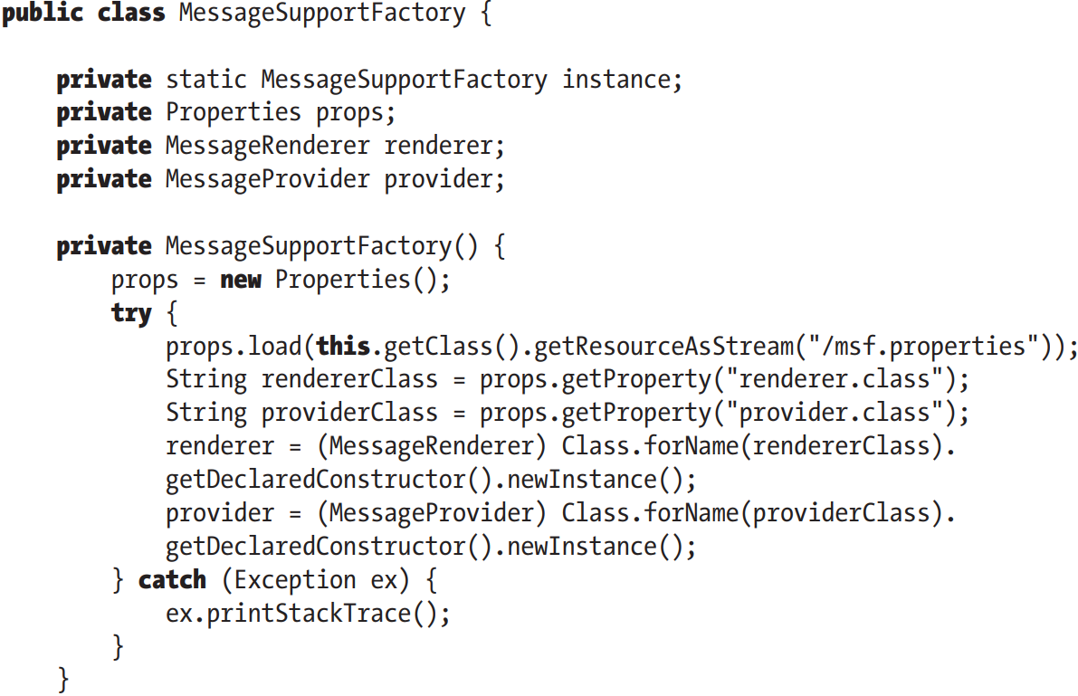

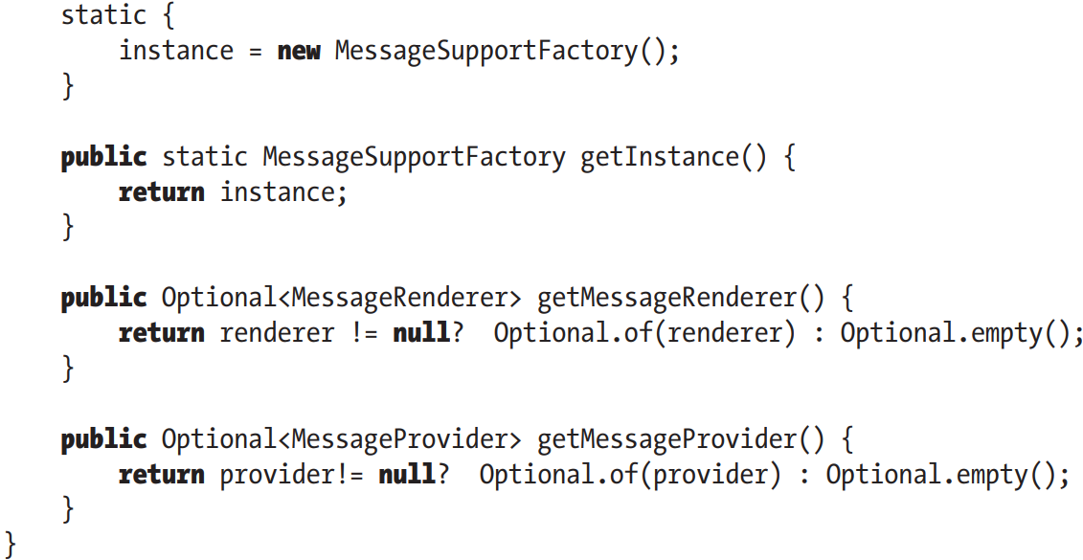

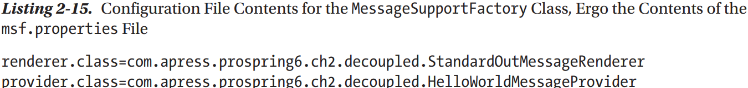

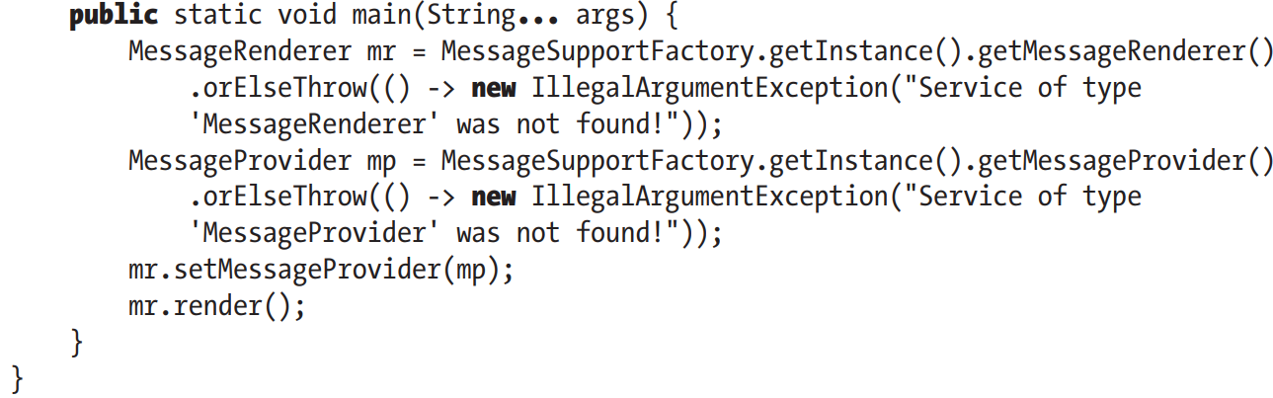

-There is already a class **ServiceLoader** that does the exact thing like MessageSupportFactory. This class facilitates discovering and loading implementations matching a given interface. The interfaces that ServiceLoader retrieves implementations for are called **Service Provider Interface** (SPI)

-3 rules for configuration:

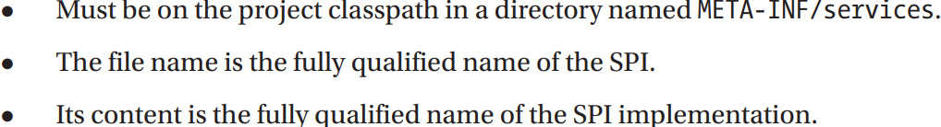

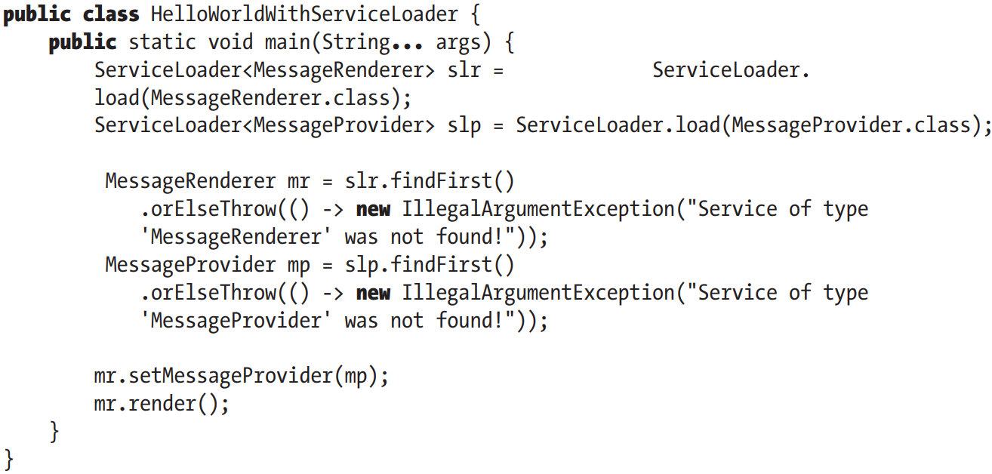

### 2.8.2 Refactor with Spring

-Use Spring XML Configuration:

+Spring interface: ApplicationContext for storing all environmental information. This interface extends ListableBeanFactory: acts as the provider for any bean instance.

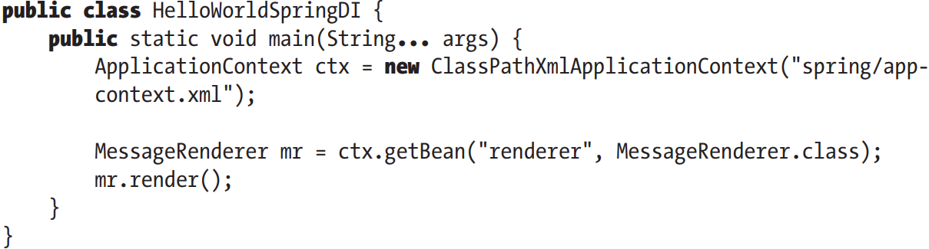

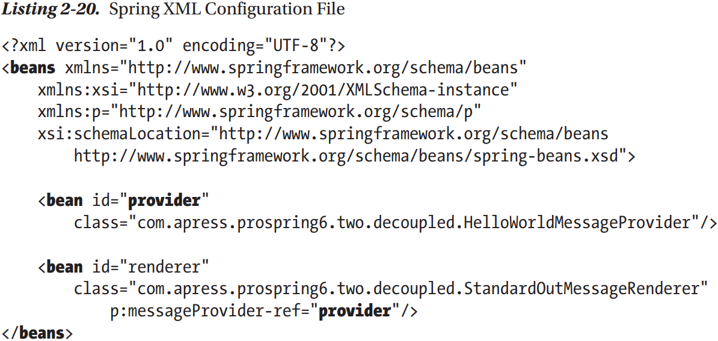

+main() just obtain MessageRenderer bean by getBean(). Spring has created MessageProvider instance and injected it into MessageRenderer instance. We didn’t have to make changes to classes that are being wired together using Spring.

-Spring Configuration Using Annotation

+Since Spring 3.0, XML configuration files can be replaced with annotations and Java configuration classes

+**Configuration classes**: Java classes annotated with **@Configuration** that contain **bean definitions** (methods annotated with **@Bean**) or are configured themselves to identify bean definitions by annotating them with **@ComponentScanning**.

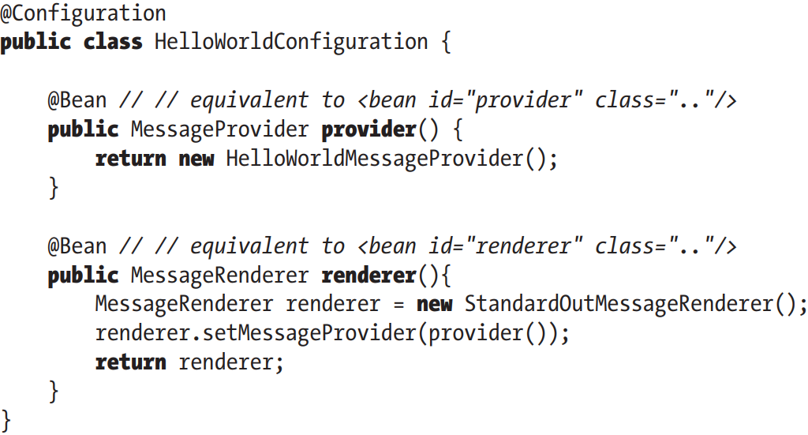

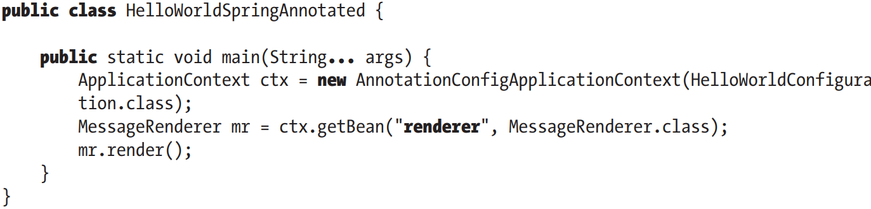

+**AnnotationConfigApplicationContext**: ApplicationContext implementation read bean definitions from configuration classes

# 3. Introduce IoC and DI in Spring

-IoC and DI from Martin Flower:



## 3.1 Inversion of Control and Dependency Injection

-IoC aims to offer a simpler mechanism for provisioning component dependencies (object’s collaborators) and managing these dependencies throughout their life cycle.

-A component that requires certain dependencies is dependency object/target.

-In general, IoC can be decomposed into 2 subtypes: dependency injection and dependency lookup. These subtypes are decomposed into concrete implementations of IoC services.

### 3.1.1 Types of IoC

-IoC is more of a mixture of old and new ideas. Dependency lookup: a component must acquire a reference to a dependency. DI: the dependencies are injected into component by IoC container.

-Dependency lookup comes in 2 types:

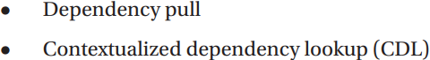

-Dependency injection has 2 types:

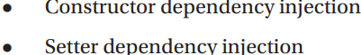

-Dependency Pull

+The most familiar type of IoC.

+Dependencies are pulled from a registry as required. Anyone who has written code to access an EJB has used dependency pull (via JNDI API to look up EJB component)

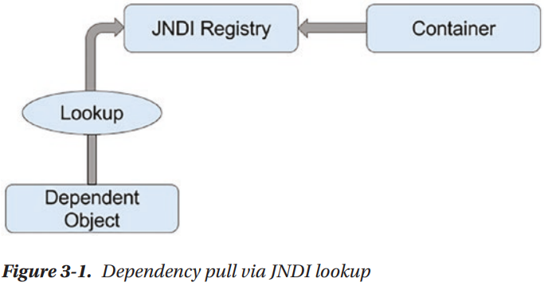

+Spring offers dependency pull as a mechanism for retrieving components that the framework manages In chap 2, we used it:

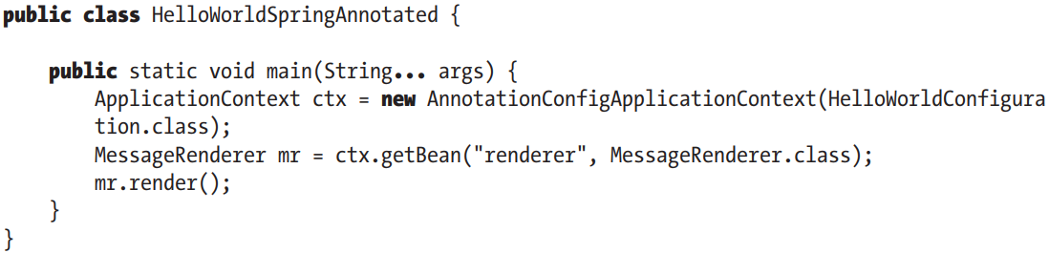

+MessageRenderer bean is retrieved from ApplicationContext that functions as a register of all beans in application. This instance is pulled, so render() can be invoked.

-Contextualized Dependency Lookup:

+Lookup is performed against the container that is managing the resource, it usually performed at some set point.

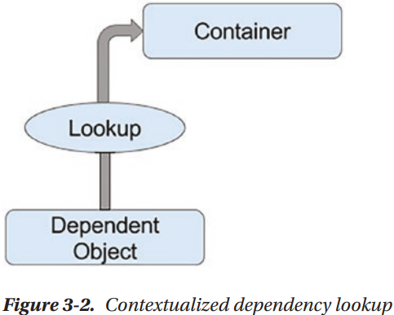

+CDL works by having the components that requires a dependency implement an interface. A component is use this interface to signal to container that it wants to obtain a dependency.

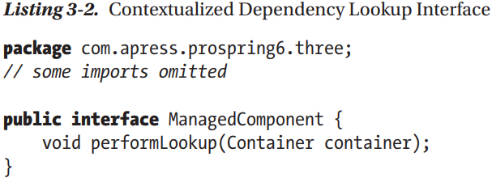

+Container is usually provided by application server(Tomcat, JBoss) or framework (Spring).

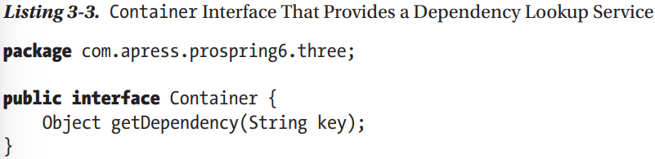

+When container is ready to pass dependencies to component, it calls performLookup() on each component in turn. Component can then look up its dependencies by using Container interface

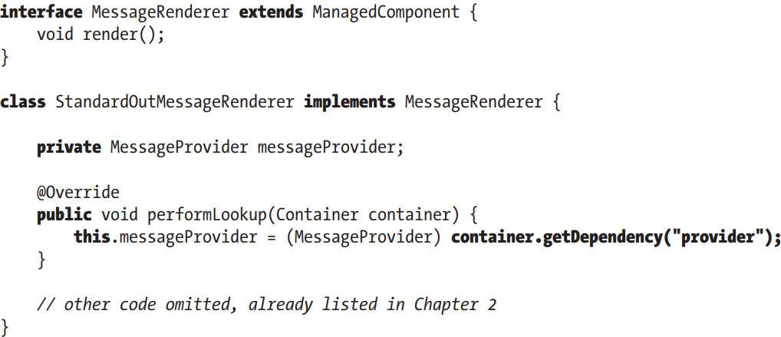

-Constructor DI

+IoC container injects component’s dependencies via its constructor. Component declares constructor(s), taking arguments as dependencies, IoC container passes dependencies to component when instantiation occurs.

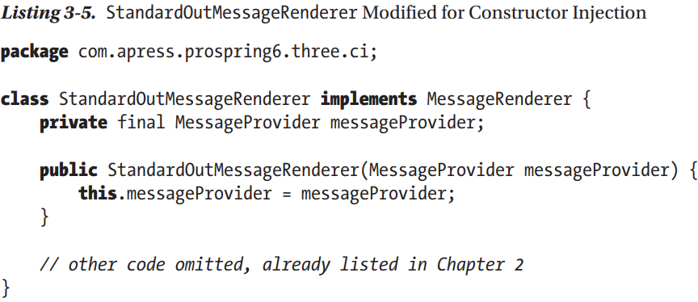

+Consequence: object can’t created without its dependencies.

### 3.1.2 Setter DI

-IoC container injects dependencies via JavaBean-style setter.

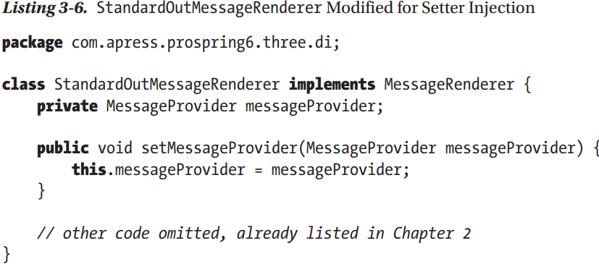

+Object can be crated without its dependencies, they can be provided later.

-Injection vs Lookup : (See in book)

### 3.1.3 Setter Injection vs Constructor Injection

-Setter Injection: allows dependencies swapped out without creating new objects, let your class choose appropriate default.

-Constructor Injection: ensure dependencies are being passed to component, when designing for immutable objects.

## 3.2 IoC in Spring

-IoC is a big part of what Spring does. The core of Spring’s implementation is based on DI.

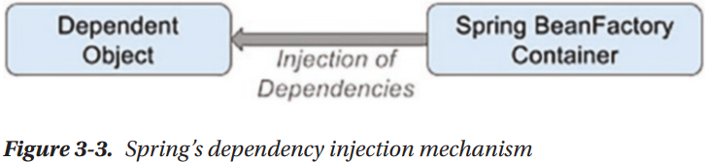

-Although DI is preferred mechanism for wiring together collaborators and dependent objects, you need dependency lookup to access dependent objects.

-Spring’s IoC container has the ability to act as an adapter between own DI container and external dependency lookup containers

## 3.3 DI in Spring

### 3.3.1 Beans and BeanFactory

-**org.springframework.beans** and **org.springframework.context** packages are the basic for Spring Framework’s IoC container.

-The central point of Spring’s IoC container is **org.springframework.beans.factory.BeanFactory** interface. Implementations of this interface are responsible for managing components: dependencies and their life cycles

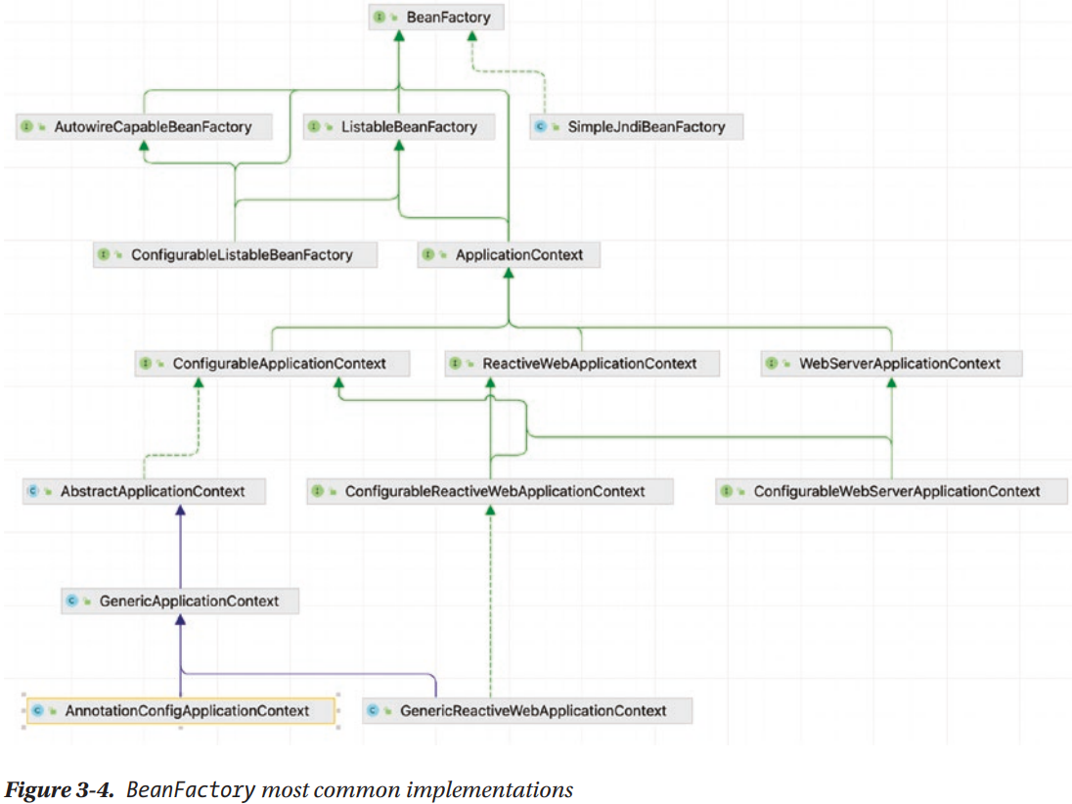

-**bean**: any object managed by Spring IoC container. Container creates, configures (assembles) and manages beans throughout their life cycle.

-If app needs only DI support, you can interact with container via BeanFactory.

-ApplicationContext is an extension of BeanFactory

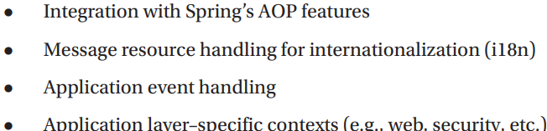

+It’s recommended that you interact with Spring via ApplicationContext. Spring support manual coding (instantiate it manually and load configuration) or in a web container environment via ContextLoaderListener

### 3.3.2 Configuring ApplicationContext

-For simple, Spring apps are configured through Java annotations and Java code

### 3.3.3 Basic Configuration Overview

-@Configuration: The class contains methods @Bean (bean declarations). This approach works for any types of object, especially 3rd party libraries

-@ComponentScan: enable class for looking existing bean declaration. The discoverable bean declarations are classes @Component and other stereotype annotations.

-All these annotations describe **configuration metadata**

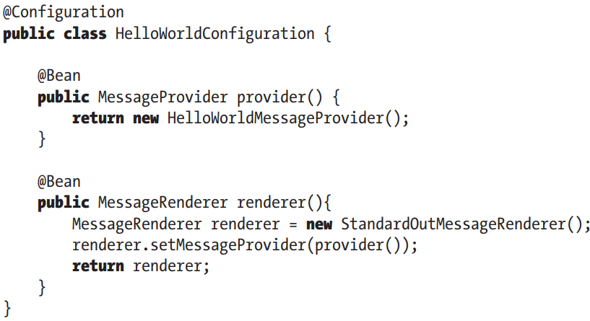

-**Configuration classes** are **bootstrapped** using AnnotationConfigApplicationContext or AnnotationConfigWebApplicationContext

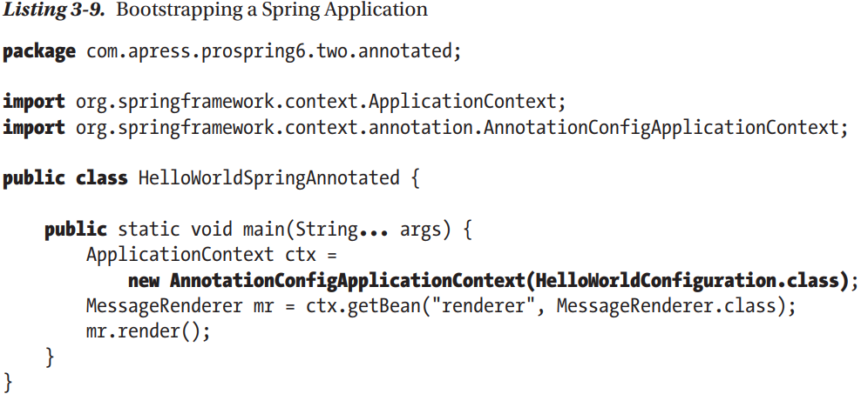

+By instantiating this class, we created an instance of Spring IoC container that read bean declaration, create the beans, add them to its registry, and manage them. Use a reference to container, beans can be retrieved and used.

### 3.3.4 Declare Spring Components

-**Stereotype** annotations: another way to declare bean

+Define the role of types or methods.

+org.springframework.stereotype

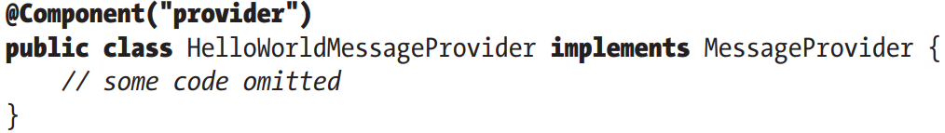

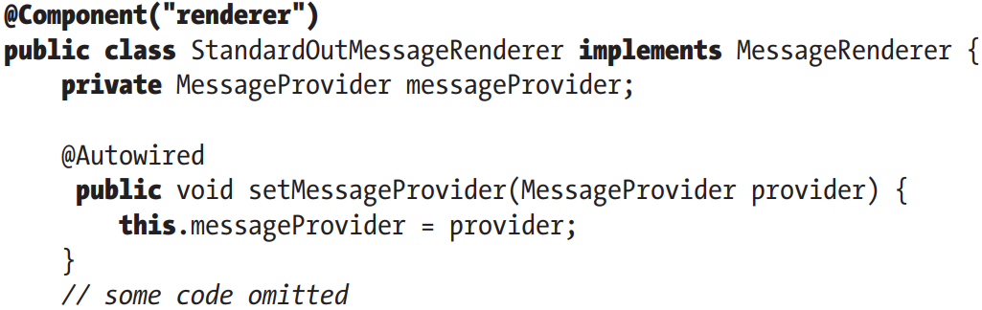

-@ComponentScan: Spring will seek out component classes, instantiate beans

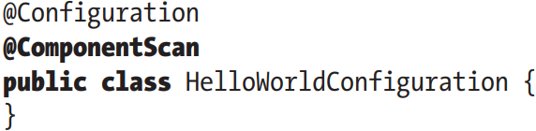

+By default, scanning occurs from configuration class package to subpackages.

+basePackages: declare package or a collection of packages for looking components

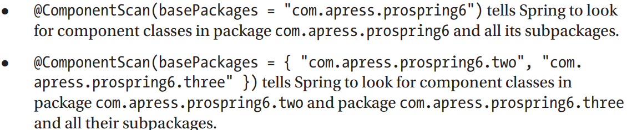

+It’s a time-consuming operation, good practice is try to limit the places Spring will look for bean definition

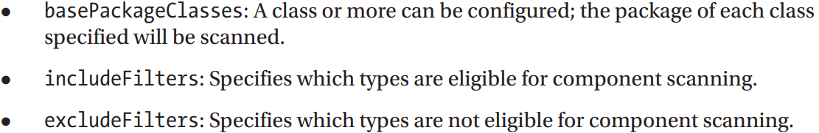

**-@ImportResource**: import bean definitions from XML file (or more)

**-@Import**: Import other bean definitions from Java configuration classes

### 3.3.5 Use Seter Injection

-To configure setter injection, @Autowired must be put on every setter to inject a dependency.

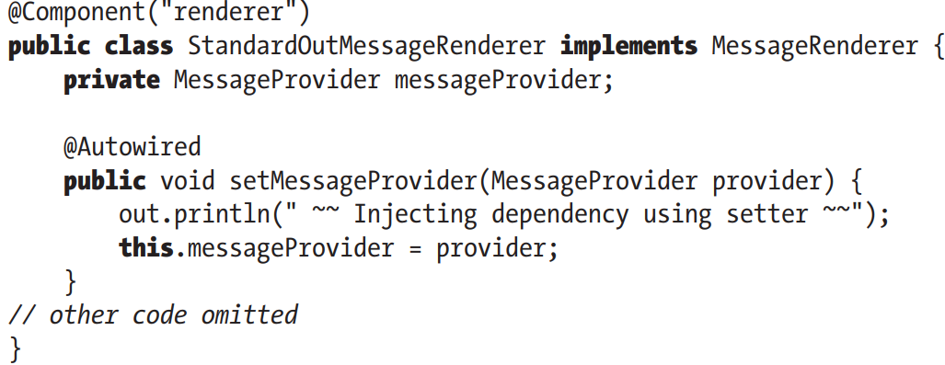

-Instead of @Autowired, you can use @Resource(name=”provider”) . It’s one of annotations in JSR-250. It supports name parameter for more fine-grained DI requirements

-@Inject from JSR-330 = @Autowired

### 3.3.6 Use Constructor Injection

-Make sure a bean is not even created without its dependencies, you can declare dependency as argument for constructor

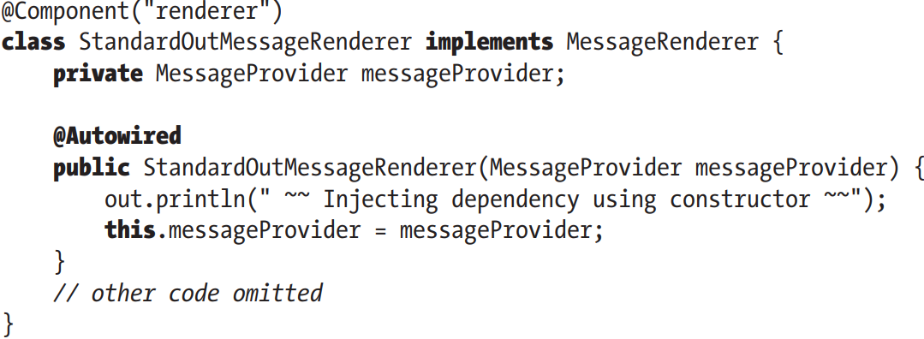

-In Spring 4.X, Spring IoC call only constructor present to create the bean regardless of presence/absence of annotation. Single constructor initializing all dependencies doesn’t require @Autowiring too.

### 3.3.7 Use Field Injection

-This is the 3rd type of DI supported in Spring

-Dependency is injected into filed.

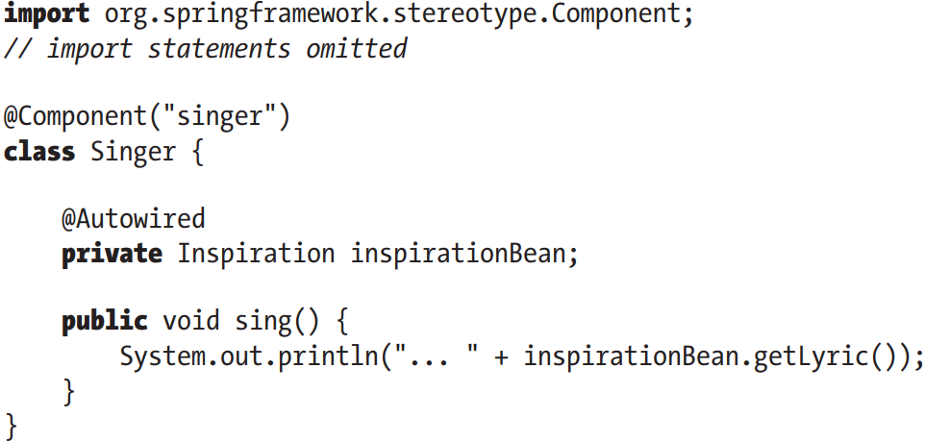

+The field is private, but container uses reflection to populate the dependency

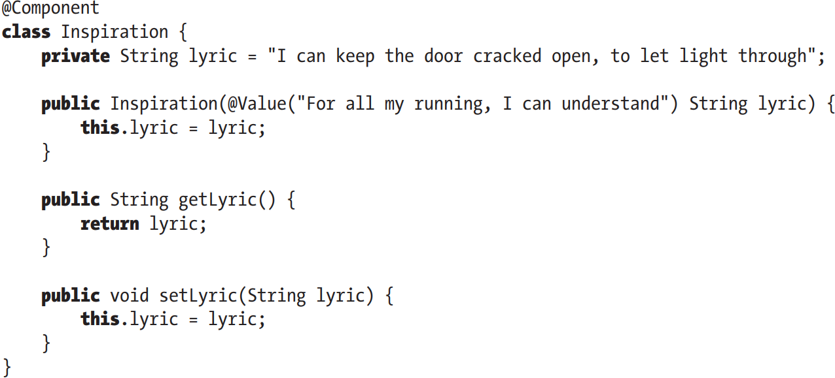

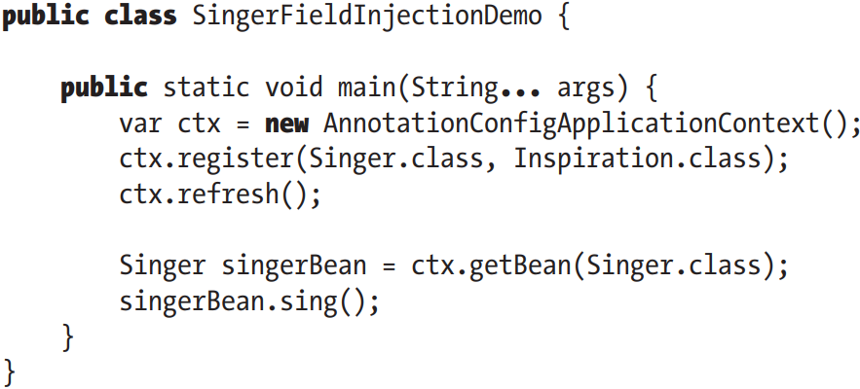

-Field injection isn’t recommended (can’t used for final fields, difficulties writing tests…). Howerver, it’s practical to use it for @Configuration and @Test clases (Integration Test)

## 3.4 Use Injection Parameters

-Spring support many options for injection parameters=inject simple values and Java collections, externally defined properties, beans in another factory

### 3.4.1 Inject Simple Values

-@Value: inject simple values into beans. By default, it can read String, but can convert to primitive or primitive wrapper.

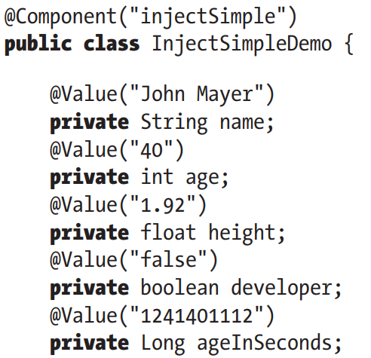

### 3.4.2 Inject Values Using SpEL

-Spring Expression Language (SpEL): evaluate an expression dynamically and then use it in ApplicationContext. You can use the result for injection into beans.

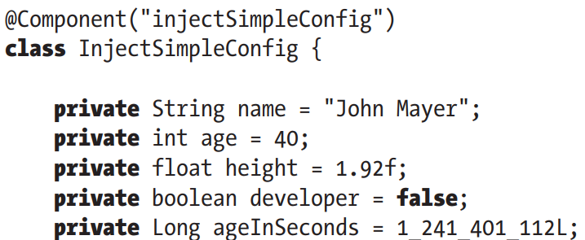

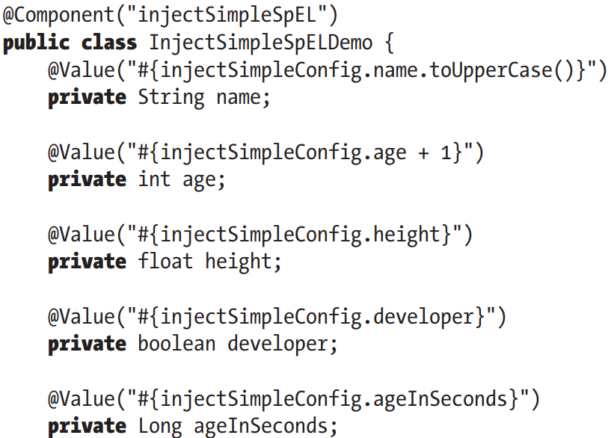

### 3.4.3 Injection and ApplicationContext Nesting

-Spring supports a hierarchical structure for ApplicationContext so that one context is considered the parent of another. It allows you to split configuration into different files

(See in books)

### 3.4.4 Inject Collections

-Often beans need access to collections of objects rather than individual beans or values. Just declare method @Bean in configuration class that returns List, Set, Properties, Map.

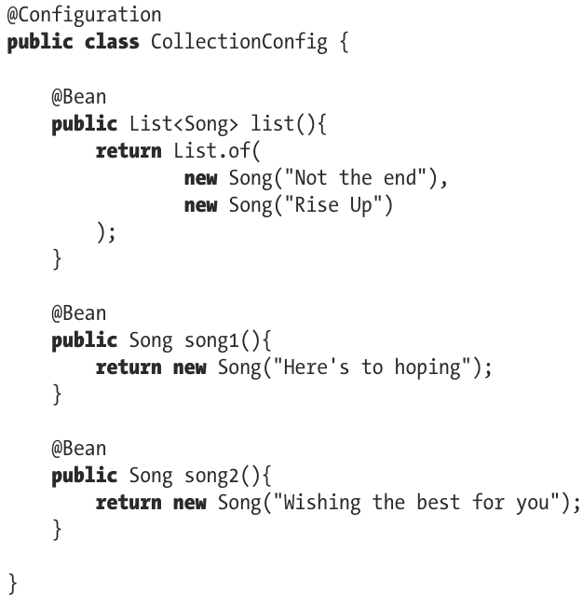

-Inject list bean:

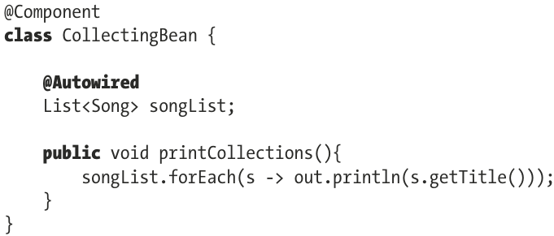

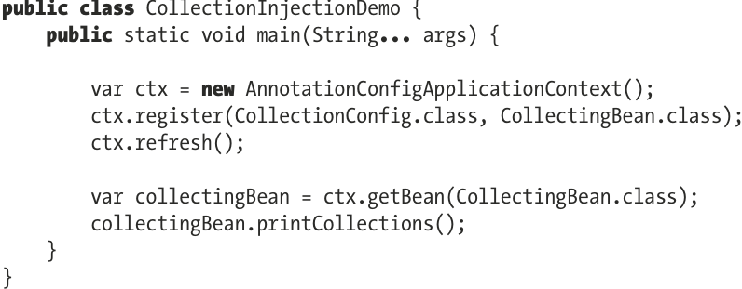

+@Autowired treats arrays, collections and maps as sets of corresponding beans, with target bean type derived from declared collection value type. So with List<Song>, Spring will try to inject all beans of type Song in current ApplicationContext.

-For collection type injection, we have to explicitly instruct Spring to perform injection by @Qualifier in springframework.beans.factory.annotation.

-Beside, there are 3 additional ways:

+@Inject @Named(“list”) in jakarta.inject: @Inject=@Autowired and @Named=@Qualifier

+@Resource(name=”list”) in jakarta.annotation

[+@Value(“#{colelctionConfig.list}”)](mailto:+@Value()” the recommended way to inject collections

-**Note**: The behavior above can applies for Set, Mapp: Map will inject {beanName, bean}

## 3.5 Use Method Injection

-Another less frequently used DI feature that Spring provides. It comes in 2 loosely related forms:

+Lookup Method Injection: another mechanism by which a bean can obtain one of dependencies

+Method Replacement: replace implementation of any method on bean arbitrarily

-(See in book)

### 3.5.1 Lookup Method Injection

### 3.5.2 Considerations for Lookup Method Injection

## 3.6 Understand Bean Naming

-Every bean must have at lean one name that is unique within ApplicationContext. Spring follows a resolution process to determine what name is used for bean

+XML configuration: give <bean> id attribute

+Java configuration: unless explicitly configured, Spring generates bean names using strategies. When retrieving beans, bean names or bean types can used, or both can be used.

### 3.6.1 Default Bean Naming Style for Beans Declared with @Component

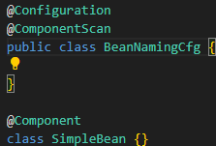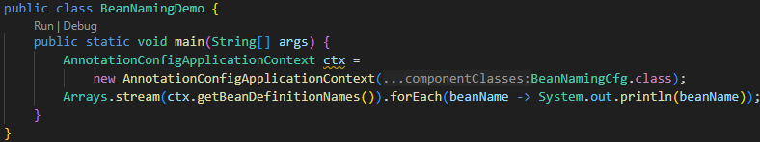

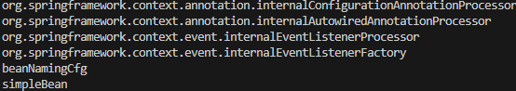

-beans with org.springframework are infrastructure beans: internally used by Spring to process bean definition and create beans

-When bean names aren’t configured explicitly, Spring takes the name of type declaring the bean, change 1st letter to lowercase.

### 3.6.2 Customize Bean Naming Style

-**Bean class naming** can be customized with ComponentScan attribute: nameGenerator. The attribute value must be a class implementing org.spring.framework.beans.factory.support.BeanNameGenerator or extend implementations.

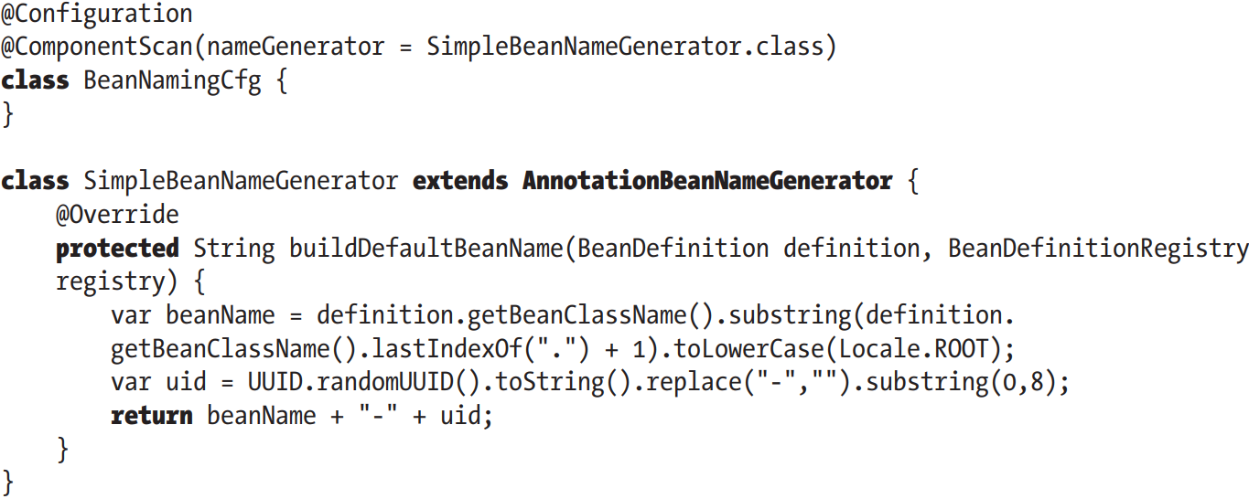

-AnnotationBeanNameGenerator used for bean classes @Component.

-@Configuration class isn’t discovered through component scanning since this class enables component scanning with custom bean generator being processed by Spring before our generator bean is enabled.

### 3.6.3 Bean Naming Style for Beans Declared with @Bean

-@Bean methods are named as the method name.

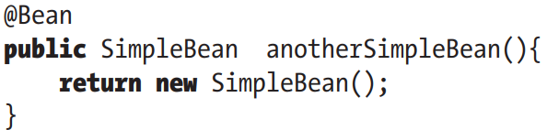

-ctx.getBean(SimpleBean.class) expects one bean of SimpleBean to be found -> exception

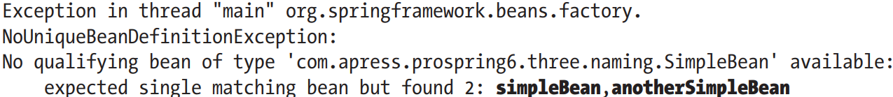

+Instead, use getBeansOfType():

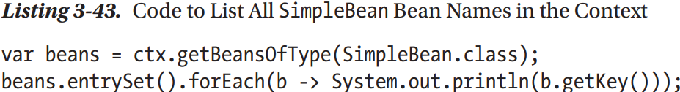

+They keys of map are bean IDs

### 3.6.4 Explicit Bean Naming

-For @Component and stereotype annotations, use default value attribute (default means you can skip type the attribute name)

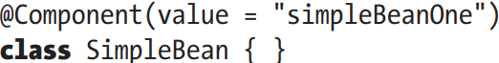

-For @Bean use default attribute value One value is a name. Array: 1st value is name and rest become alias

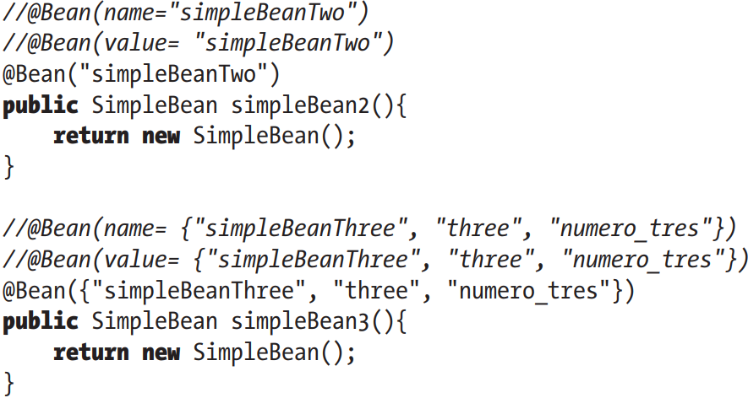

### 3.6.5 The @AliasFor Annotation

-@AliasFor: declare aliases for annotation attributes, most Spring annotations make use of it.

+Example: @Bean has name and value attributes which are declared as aliases for each other.

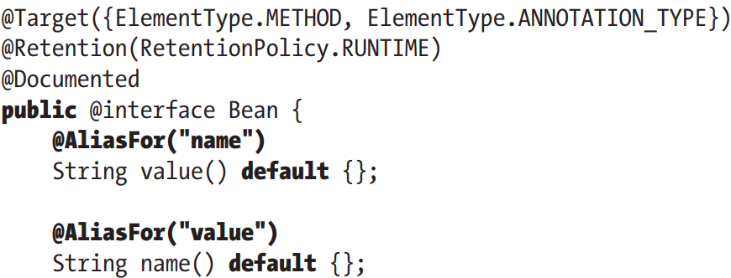

-(See in book)

### 3.6.6 Understand Bean Instantiation Mode

-Singleton Bean: created only once within context

-Prototype Bean: created every time they are requested from context.

-By default, all beans in Spring are singletons. Spring maintains a single instance of bean, all dependent objects use the same instance, all calls to ApplicationContext.getBean() return the same instance -> We can use == for comparison to check

-Term singleton refers 2 distinct concepts:

+An object having a single instance within the application.

+Singleton design pattern

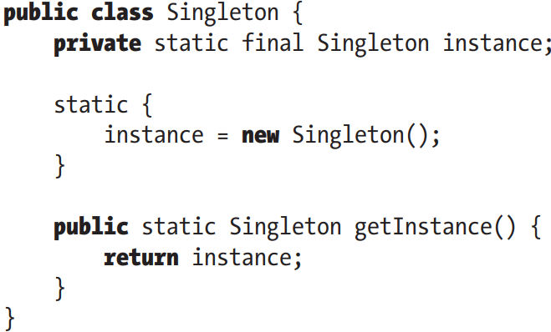

-Change instantiation mode from singleton to prototype: @Scope with scopeName

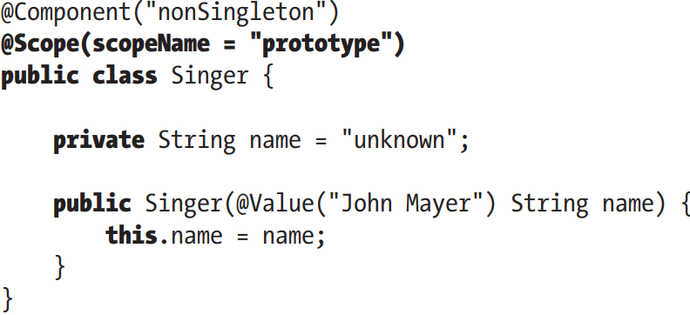

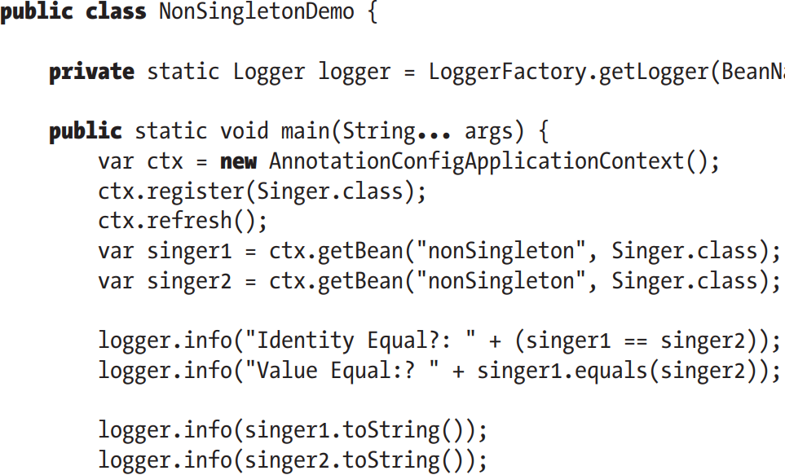

## 3.7 Choose an Instantiation Mode

-Typically, singleton is default mode for beans: shared object with no state, shared object with read-only state, shared object with shared state, high-throughput with writable state.

-Use non-singletons: Objects with writable state, objects with private state

-(See in book)

## 3.8 Additional Bean Scope

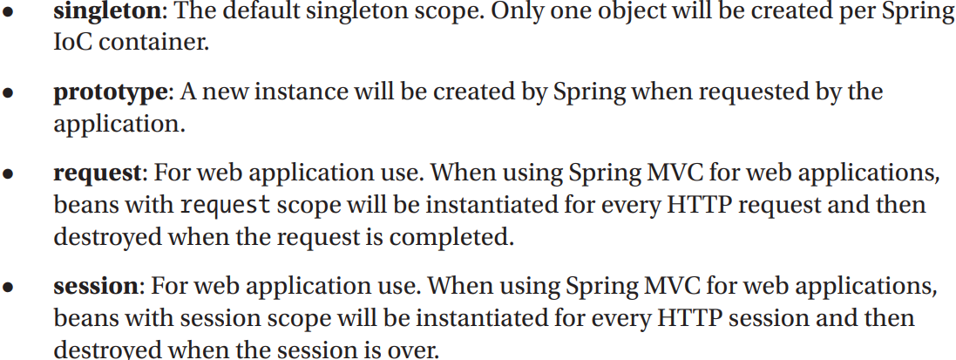

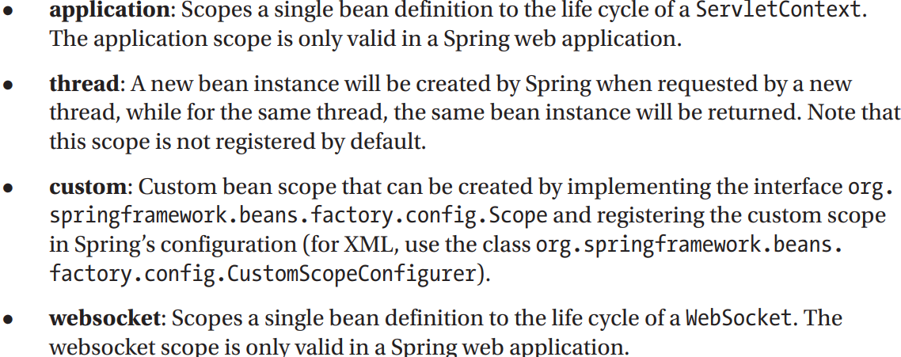

## 3.9 Resolving Dependencies

-Spring is not aware of any dependencies that exits between bean in you code that aren’t specified in configuration.

-@DependsOn: Additional Information about your bean dependencies

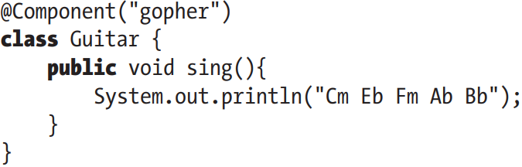

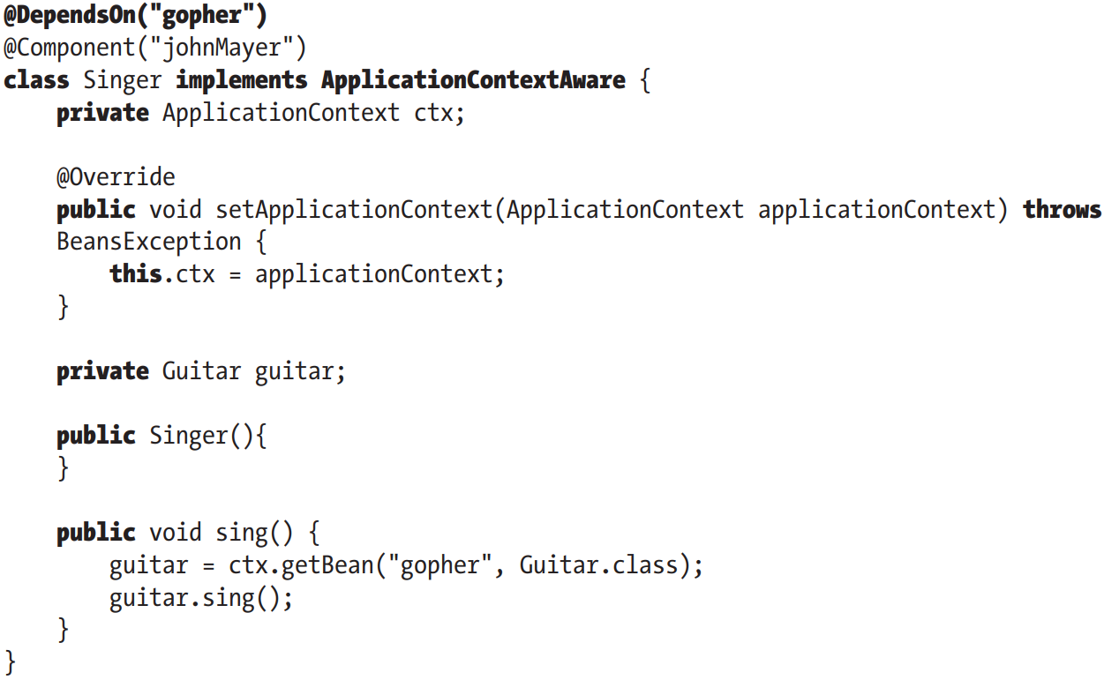

-Avoid using the feature. Define your dependencies by setter and constructor injection.

## 3.10 Autowiring Your Bean

-Autowring: the process of implicitly injecting beans into beans depending on them. Spring supports 5 modes for autowiring:

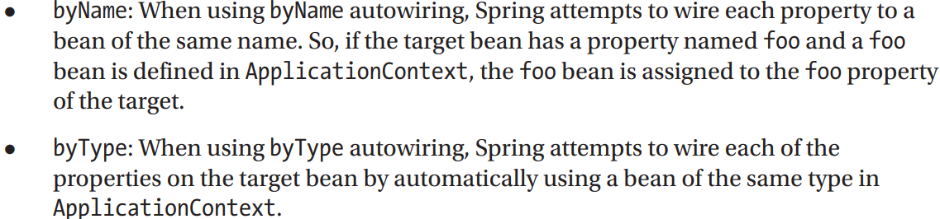

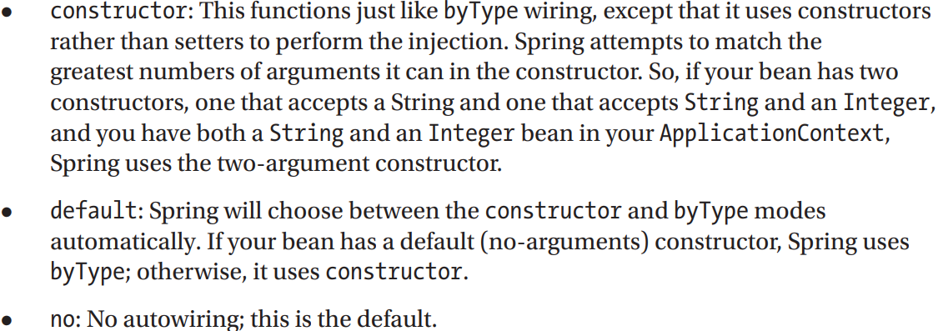

### 3.10.1 Constructor Autowiring

-When a dependency is provided using constructor injection, autorwiring is done through constructor.

-If class has more than one constructor

+If none of them @Autowired, the most suitable will used. If more than one suitable, Spring uses no-argument constrictor if there is one. If there is none-> BeanInstantiationException

**-@Lazy**: instantiate bean only when it’s 1st requested

### 3.10.2 byType Autowiring

-When there are no constructor declared but there are setter @Autowired, Spring will use them and will identify beans injected based on their type.

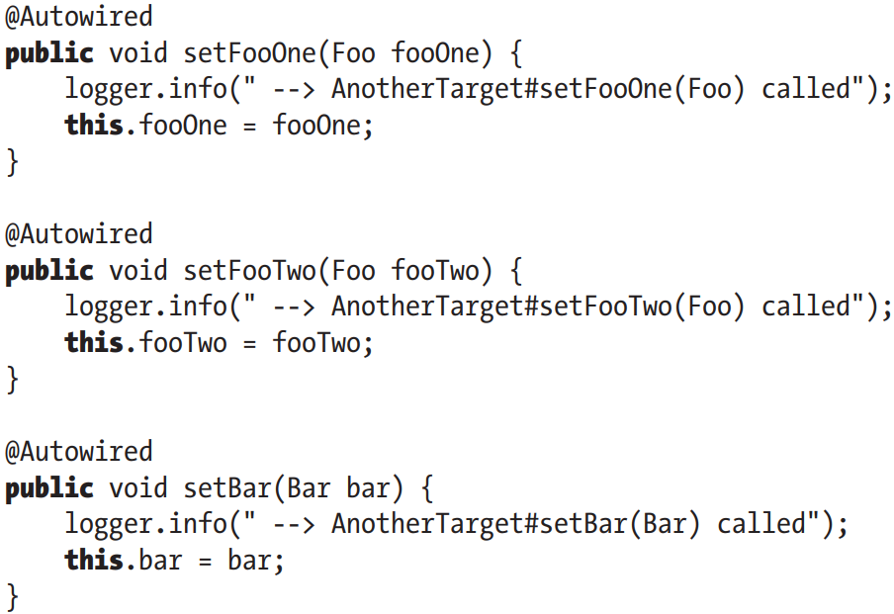

-Also, Spring injects dependencies by type for fields @Autowired, but it’s discouraged

-There is a single Foo bean and that bean injected in both fooOne and fooTwo. If we declare another Foo bean: dependencies are autowired by type are there are 2 dependencies of type Foo being required and Spring can’t figure out which of the 2 Foo beans are required where.->NoUniqueBeanDefinitionException

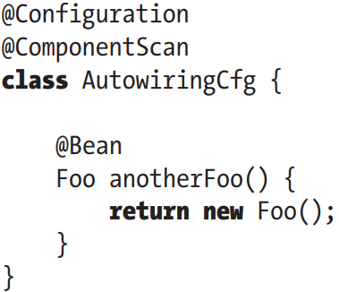

### 3.10.3 byName Autowiring

-Use @Qualifier on argument:

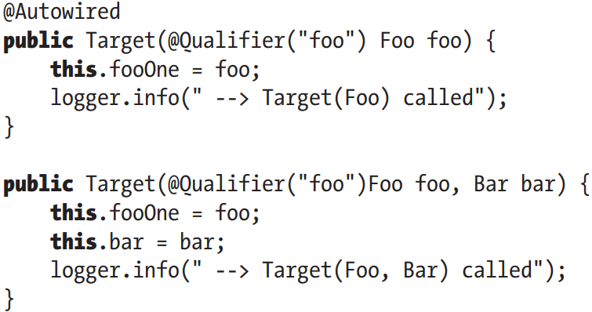

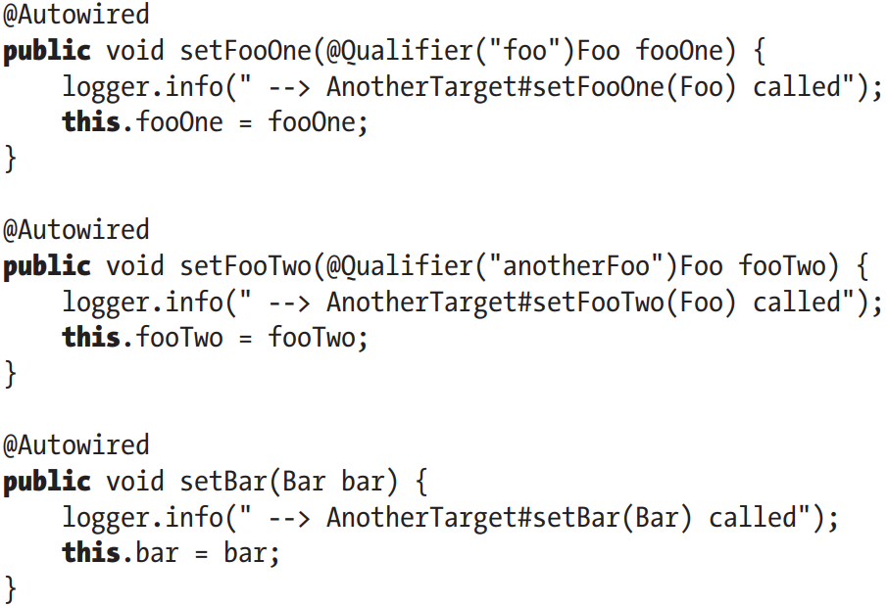

-If you use @Inject instead of @Autowired, use @Named instead of @Qualifier.

-Use @Qualifier for Field Injection

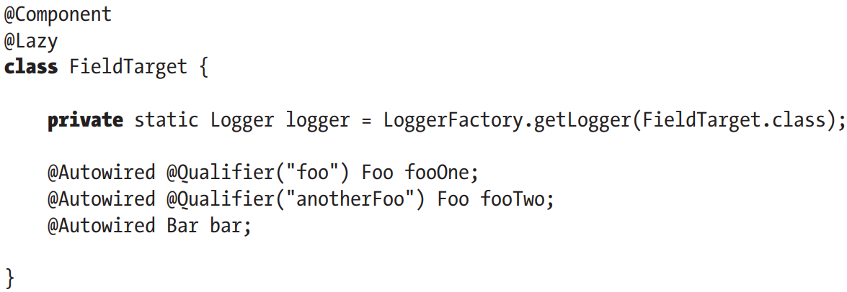

### 3.10.4 Yet Another Pickle

-When autowiring by type, exceptions are thrown when you have more classes that implement the same interface and property requiring to be autowired specifies the interface as the type, as Spring doesn’t know which bean to inject.

-We can transform Foo into an interface and declare 2 bean types implementing it with bean declaration. The configuration is the default one with bean names generated by Spring

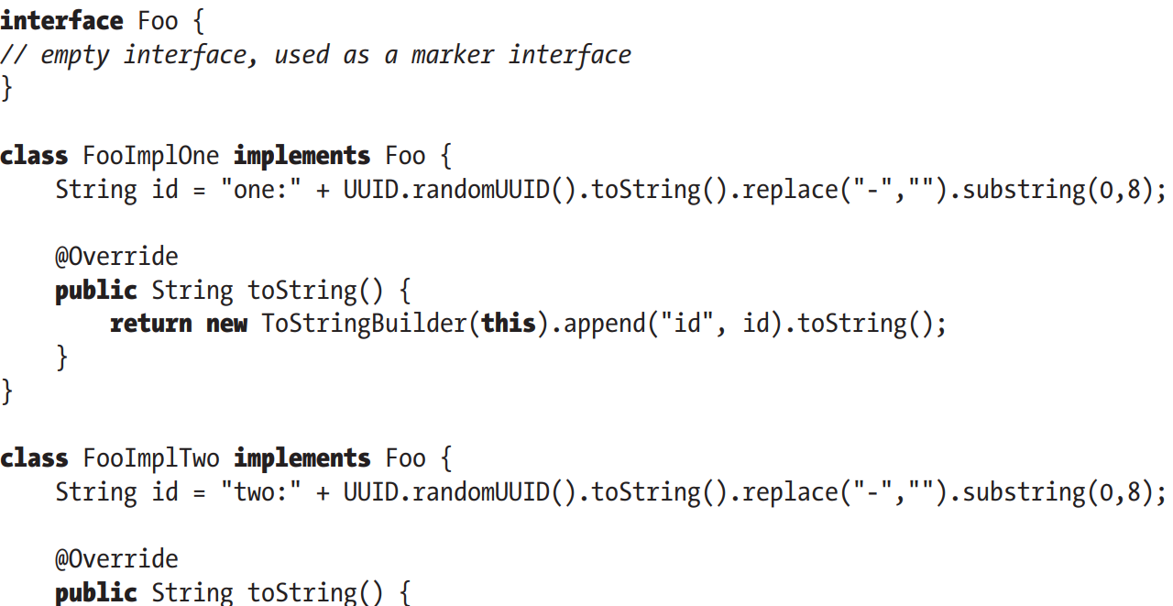

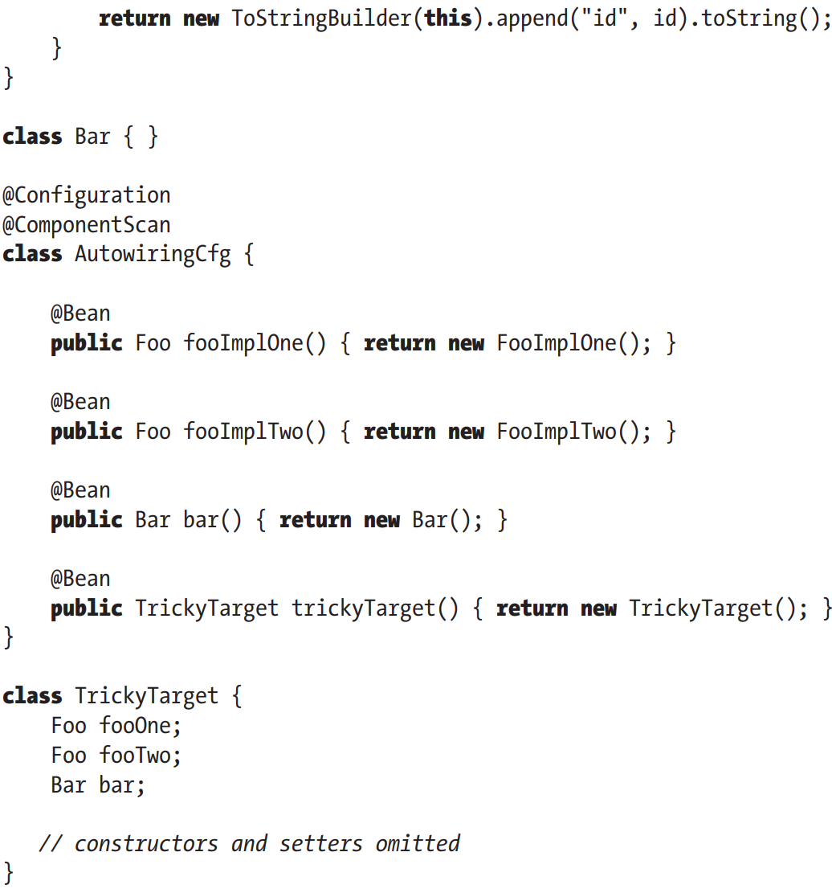

-When Spring doesn’t know what bean to autowire, it throws NoUniqueBeanDefinitionException. It tells what beans were found but that it can’t choose which to use where. There are 2 ways to fix this problem:  
+**@Primary** in bean definition that you want Spring to consider 1st for autowiring

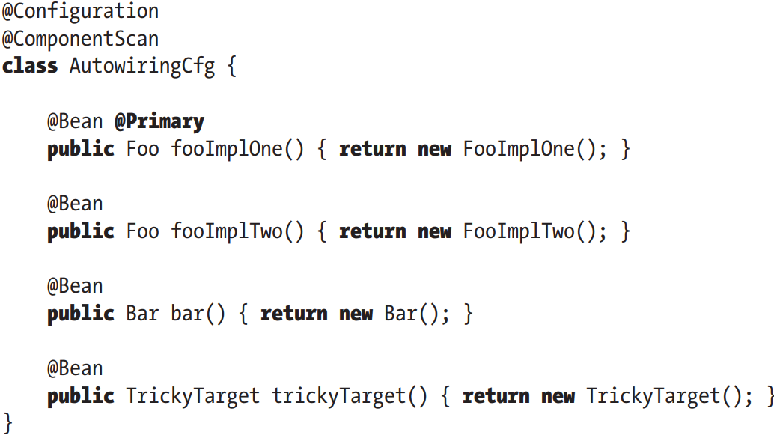

Use @Primary only when there are just 2 bean-related types.

**+@Qualifier**

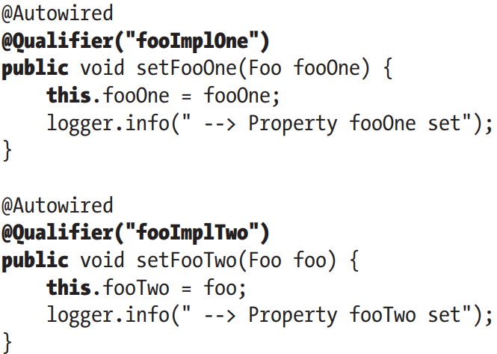

### 3.10.5 When to Use Autowiring

-The question is not when you should use autowiring, but which type of autowiring is suitable for certain parts of your applications.

-byType, constructor autowiring: only one bean for each type in ApplicationContext

-Explicit define wiring: benefit from property naming, how many instances of same type you manage…

# 4. Advanced Spring Configuration and Spring Boot

## 4.1 Spring’s Impact on Application Portability

-(See in book)

## 4.2 Bean Life-Cycle Management

-An important part of IoC container: beans can be constructed that they receive notifications at certain points in their life cycle. This enables beans to perform relevant processing at certain points.

-2 life-cycle events relevant to bean:  
+post-initialization: raised when Spring finishes setting all property value on bean and finishes any dependency checks that you configured it to perform

+pre-destruction: before Spring destroys bean instance, but not for prototype bean

-Spring has 3 mechanisms a bean can use to hook into each of these events:

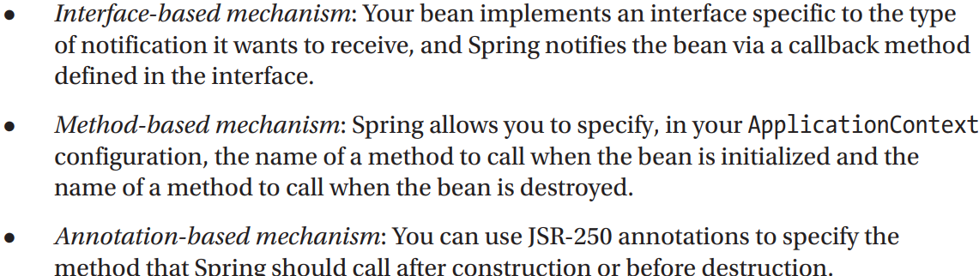

-High-level overview of how Spring manages the life cycle of beans:

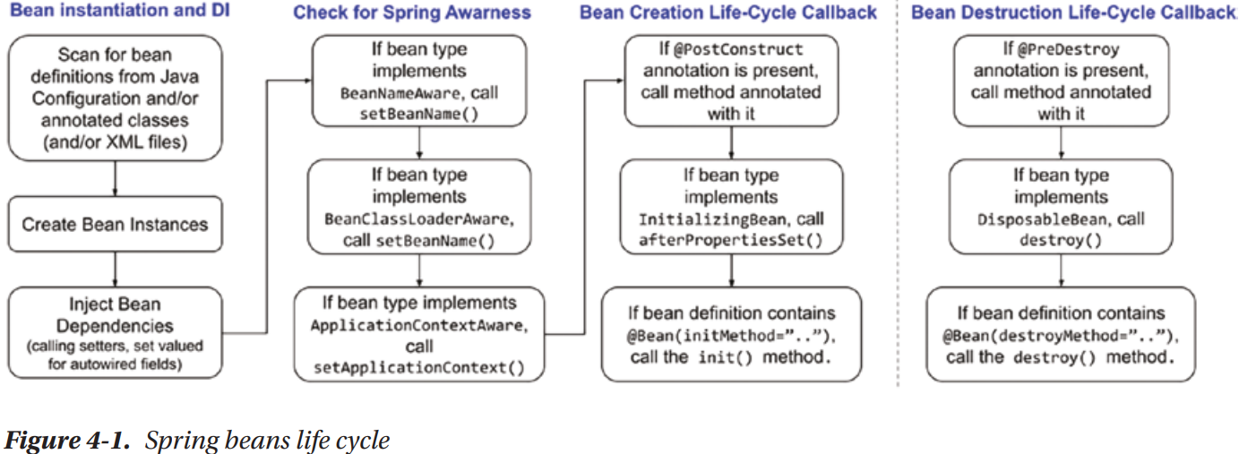

## 4.3 Hooking into Bean Creation

### 4.3.1 Execute a Method when a Bean is created

-set **initMethod** in @Bean

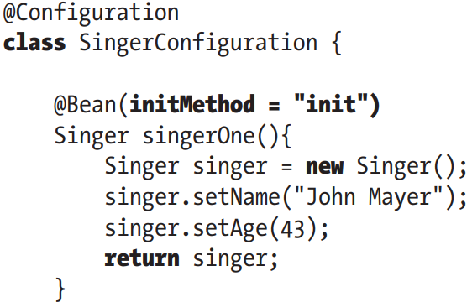

-Initialization method can’t accept any argument. You can define any return type (although Spring will ignore it) and use static method

### 4.3.2 Implement the InitializingBean Interface

-Interface **InitializingBean** and **aferPropertiesSet()**

### 4.3.3 Use the JSR-250 @PostConstruct

-Use **@PostConstruct**

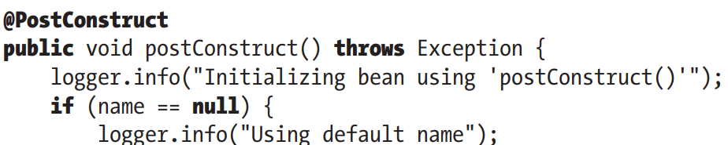

-Benefits and drawbacks of 3 appoaches:

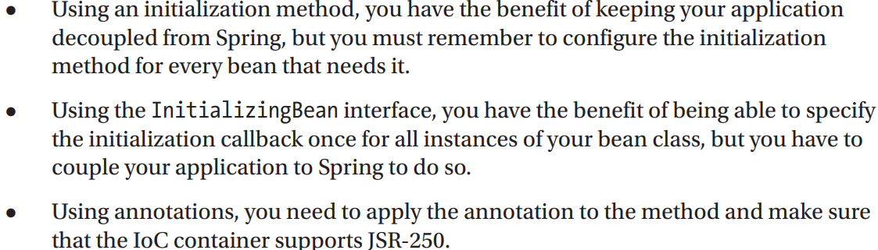

### 4.3.4 Understand Order of Resolution

-Bean creation process:

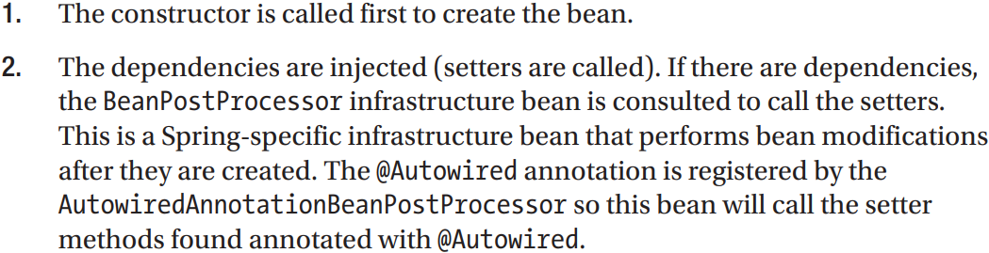

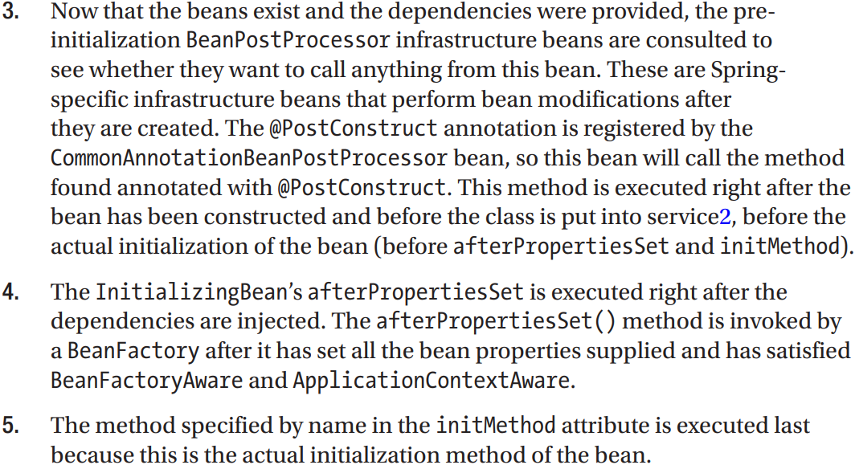

-Demonstrate the process above:

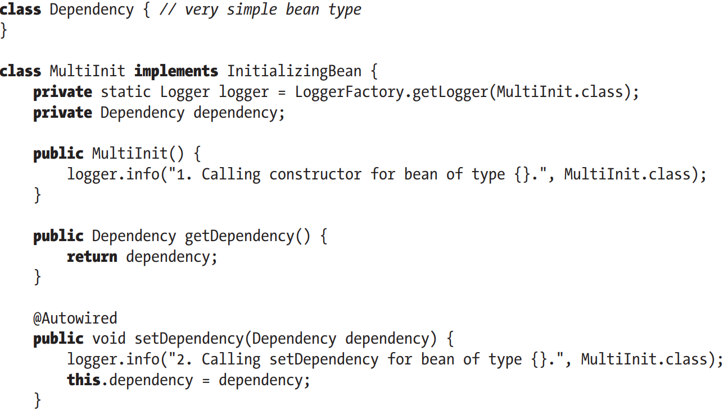

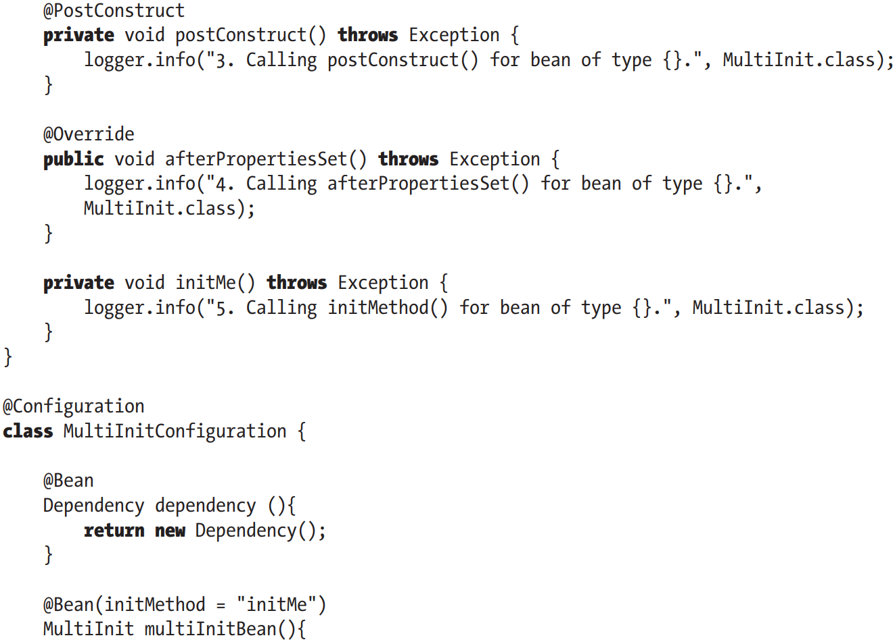

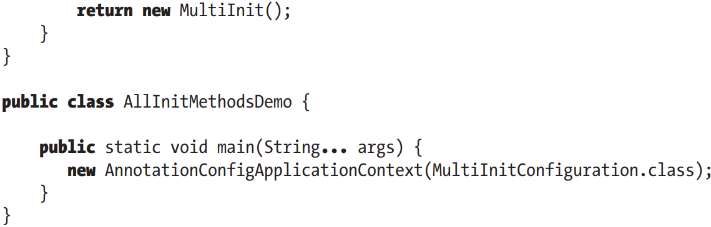

+Log:

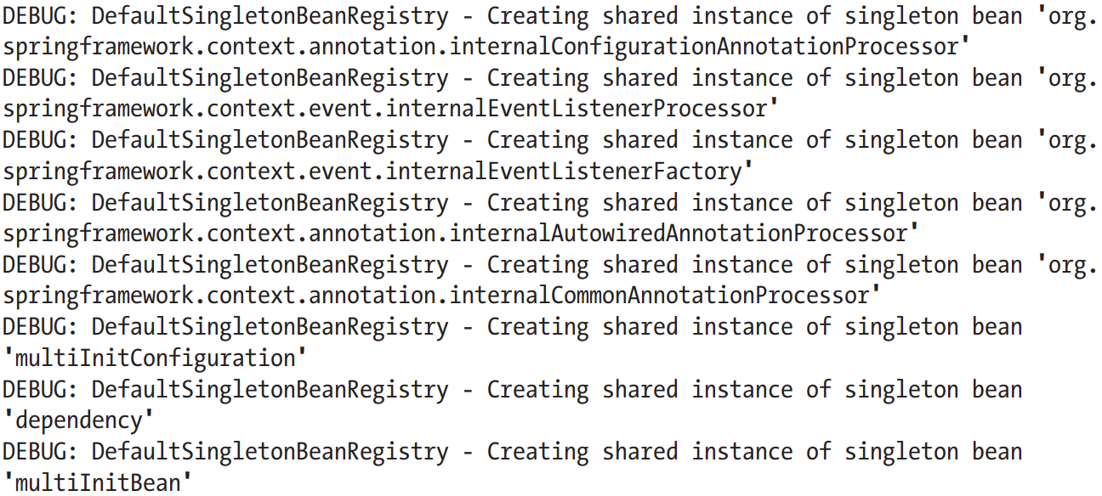

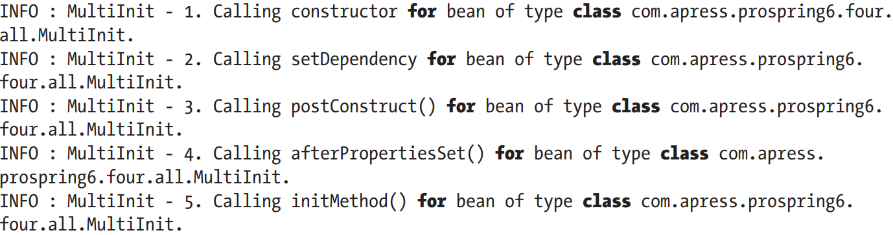

+Notice a few Spring-specific infrastructure beans. Their name hints to their type and responsibilities

+If you want to identify other types of Spring-specific infrastructure beans, look AnnotationConfigUtils: github.com/spring-projects/spring-framework/blob/main/spring-context/src/main/java/org/springframework/context/annotation/AnnotationConfigUtils.java

## 4.4 Hooking into Bean Destruction

-When using ApplicationContext implementation that wraps DefaultListableBeanFactory interface, you can signal BeanFactory to destroy all singleton instances with ConfigurableBeanFactory.destroySingletons(). This callback provides perfect place to flush any data storing in memory to persistent storage.

-To allow beans to receive notification that destroySingletons() has been called, you have 3 options like initialization callback.

-Notice that Spring only performs bean destruction for singleton beans. Beans with other scopes don’t have their life cycle fully managed by Spring.

### 4.4.1 Execute a Method when a Bean is Destroyed

-Use **destroyMethod** of **@Bean**

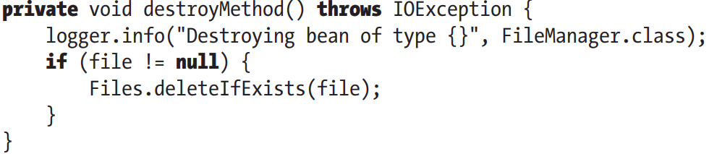

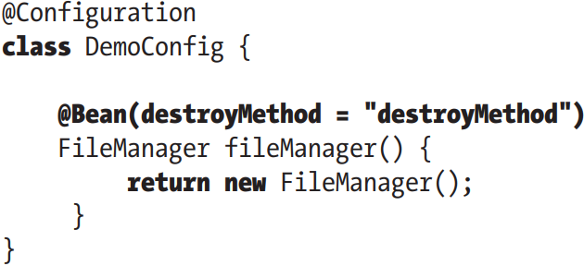

### 4.4.2 Implement the DisposableBean Interface

-**DisposableBean** interface with **destroy()**

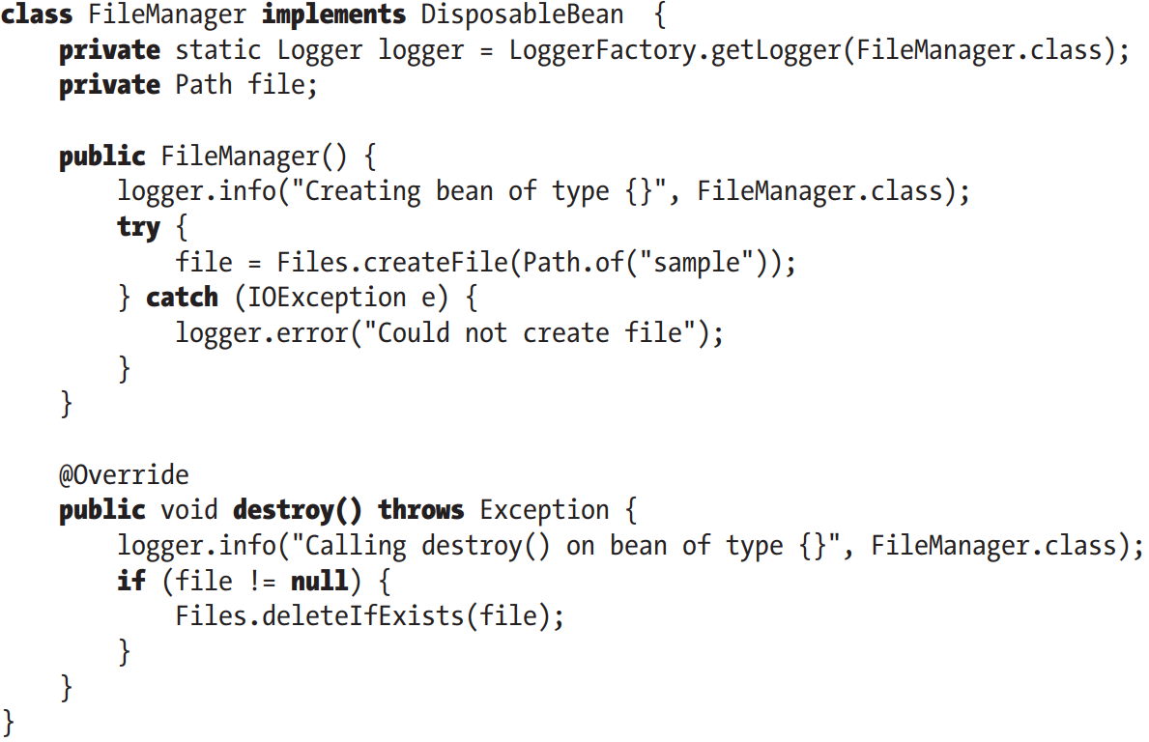

### 4.4.3 Use JSR-250 @PreDestroy

-Use **@PreDestroy** for method:

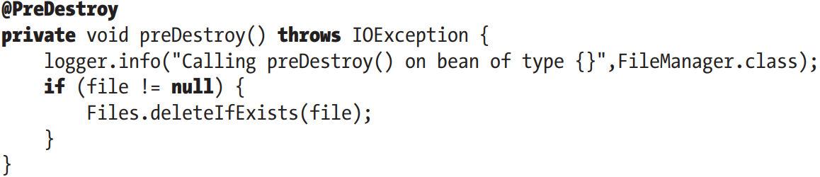

### 4.4.4 Understand Order of Resolution

-Spring invokes **@PreDesotry** method, then **DisposableBean.destroy()**, followed by **destroyMethod** in @Bean

### 4.4.5 Use a Shutdown Hook

-Destruction callbacks aren’t fired automatically, you need to call ctx.close(). But in a stand-alone app, things are not quite simple, especially if you have multiple exit points out of app.

-**shutdown hook**: a thread that is executed just before application shuts down. This is the perfect way to invoke destroy(). Use AbstractApplicationContext’s **registerShutdownHook()**: automatically instructs Spring to register a shutdown hook of JVM runtime.

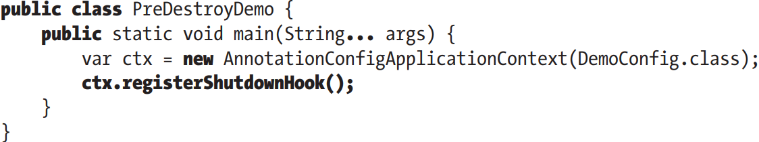

## 4.5 Make your Beans “Spring Aware”

-DI: beans don’t need to aware of implementation of container managing them. But sometimes we need a bean to interact with container. Example: bean to automatically configure shutdown hook, a bean may want to know what its name is…

### 4.5.1 Use BeanNameAware Interface

-**BeanNameAware**: implemented by a bean that wants to **obtain** its own **name**

+**setBeanName()**: Spring calls it after finishing configuring bean but before any life-cycle callbacks

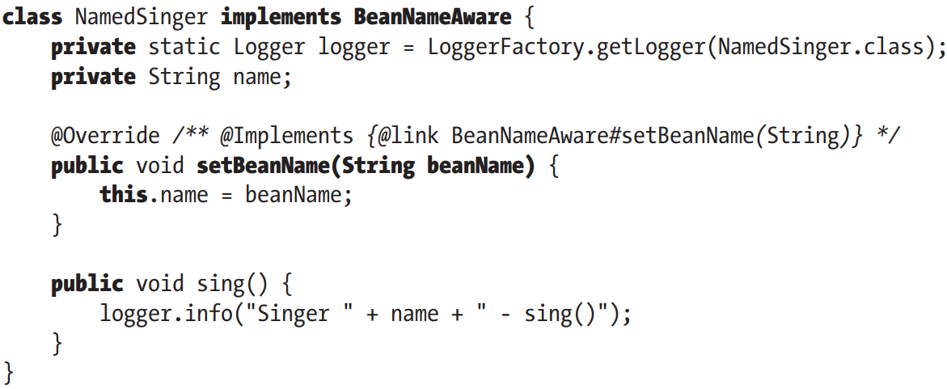

### 4.5.2 Use ApplicationContextAware Interface

-ApplicationContextAware: bean can get a reference to ApplicationContext instance.

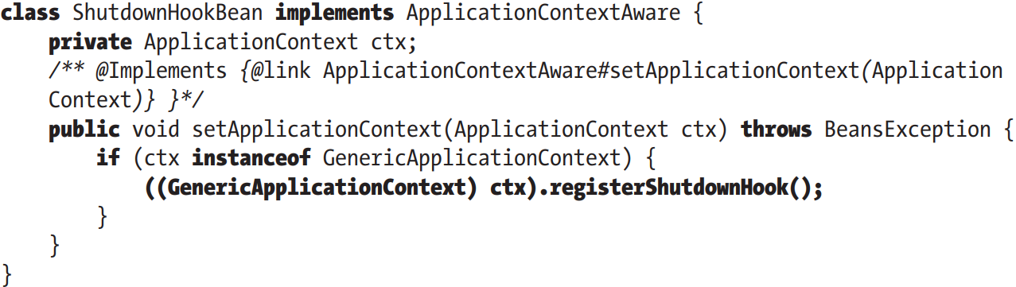

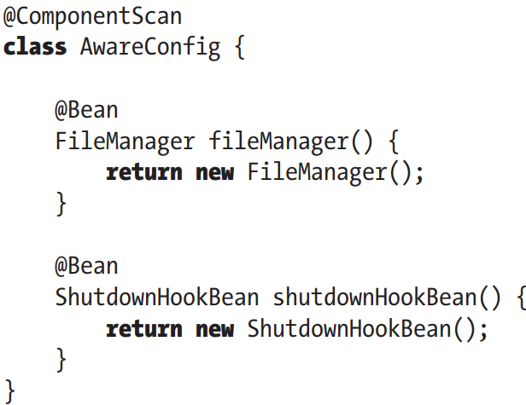

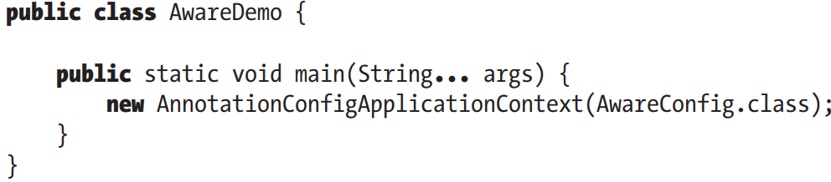

## 4.6 Use of FactoryBeans

-FactoryBean: acts as an adapter for objects that can’t be created and managed using standard Spring semantics. Typically, you use FactoryBean implementations to create beans that you can’t create by new operator (example: static factory method)

-FactoryBean is a bean that acts as a factory for other beans. FactoryBeans are configured within ApplicationContext, Sprubg invokes FactoryBean.getObject() automatically.

-FactoryBeans have great effect: transactional proxies, automatic retrieval of resources from JNDI context

### 4.6.1 FactoryBean Example

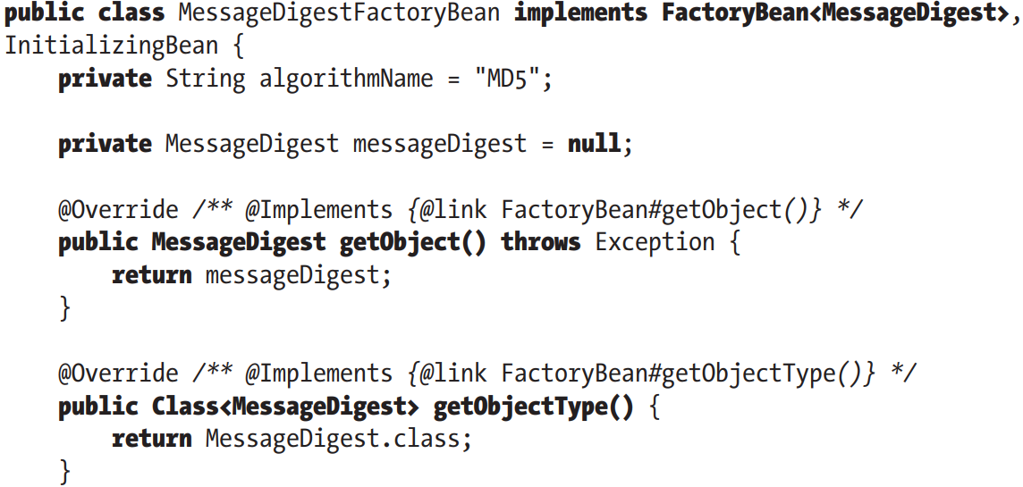

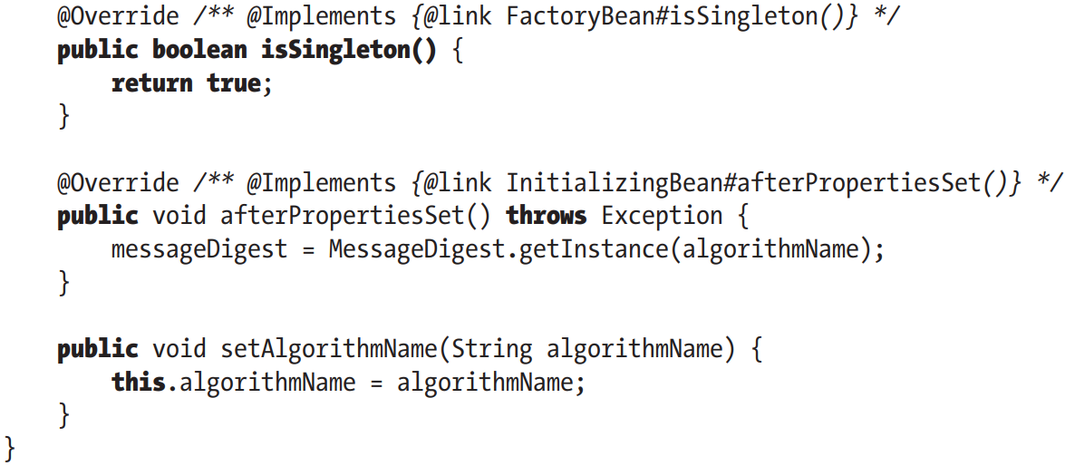

-Bean maintains 2 MessageDigest intances:

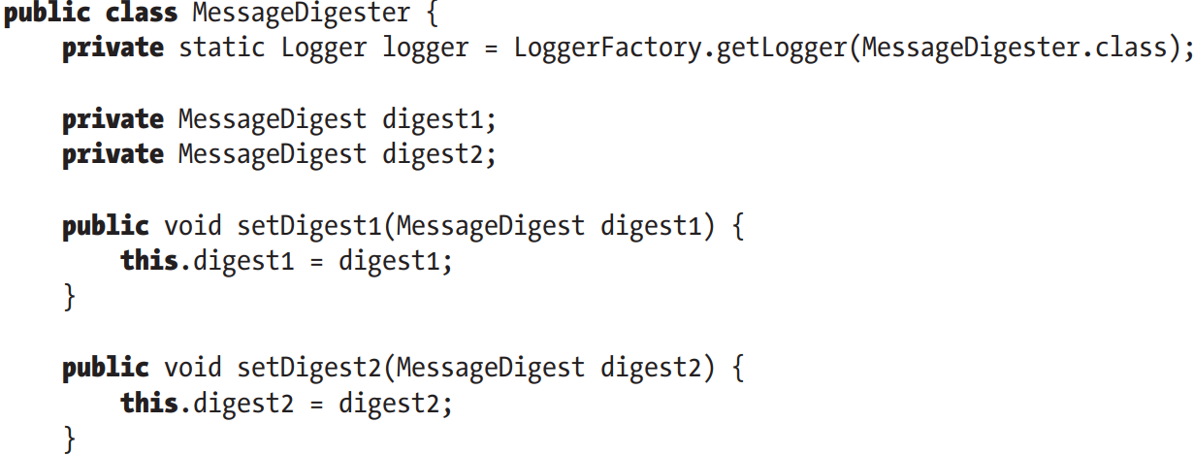

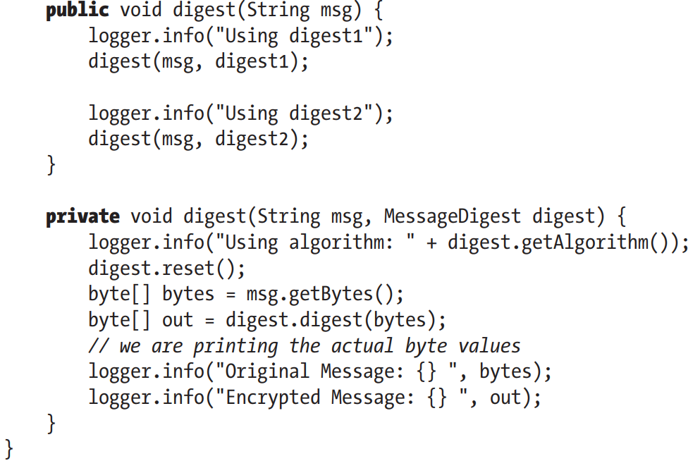

-Configuration for 2 MessageDigestFactoryBean. Them FactoryBeanDemo class retrieves bean from BeanFactory and create digest of message

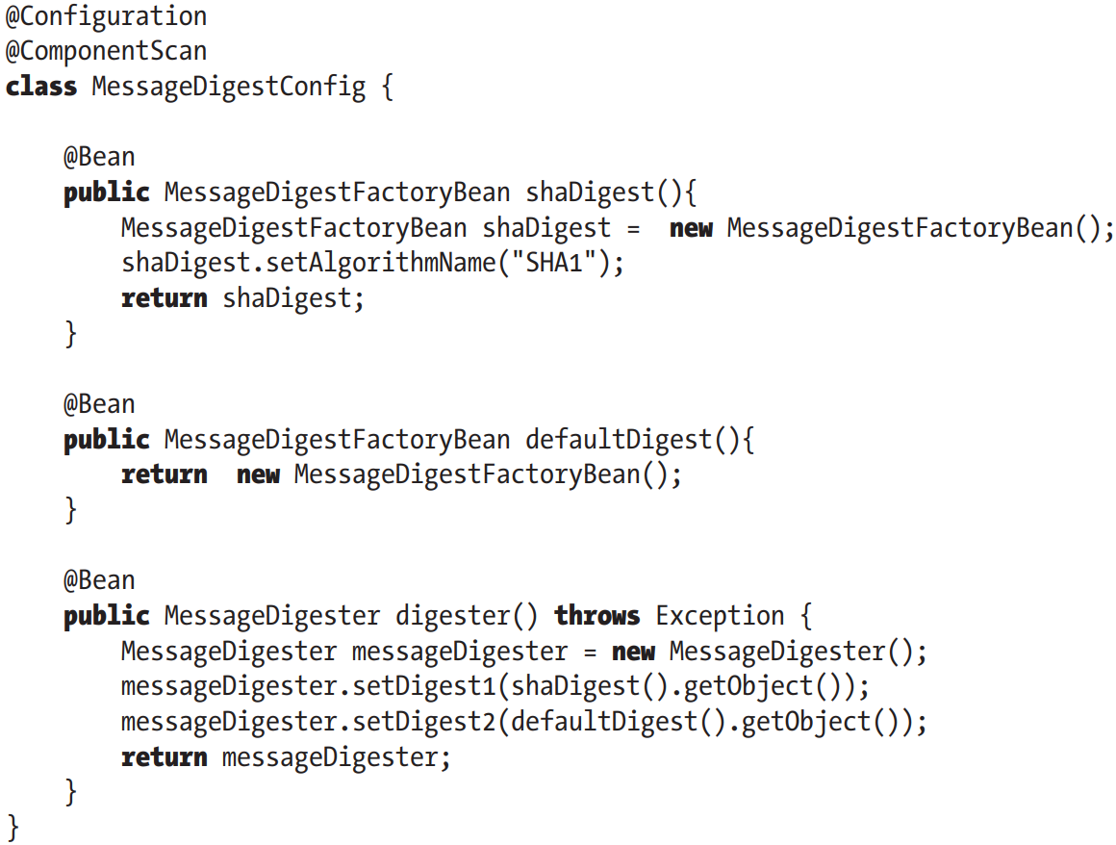

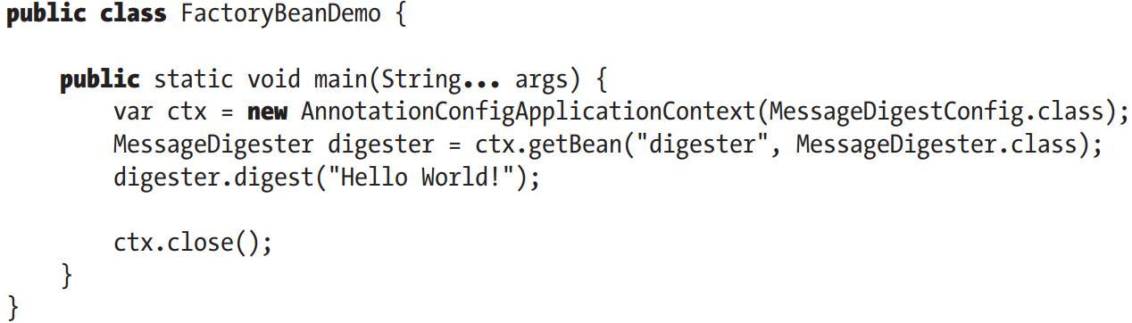

### 4.6.2 Access a FactoryBean directly

-Prefix the bean name with an ampersand in the call to getBean()

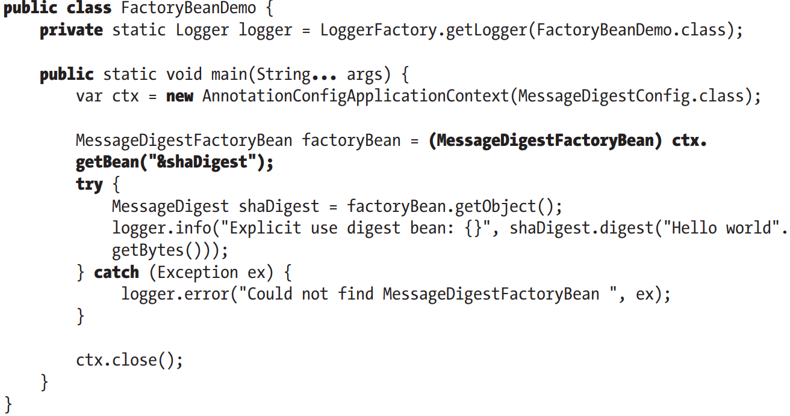

## 4.7 JavaBeans PropertyEditors

-PropertyEditor interface: converts property’s value to and from its native type representation into String.

-(See in book)

### 4.7.1 Use the Built-in PropertyEditors

-(See in book)

### 4.7.2 Create a custom PropertyEditor

-(See in book)

## 4.8 More Spring ApplicationContext Configuration

-The biggest benefit of using ApplicationContext is that it allows you to configure and manage Spring and resources. Wherever possible, Spring provides support classes to load ApplicationContext into app automatically (only when building web app with Spring). In addition to providing a model that is focused more on declarative configuration, ApplicationContext support more features

## 4.9 Internationalization

-Internationalization (i18n): Use MessageSource interface, your app can access String resources messages stored in a variety of languages.

-ApplicationContext extends MessageSource and provides special supports for loading messages and for making them available in environment.

### 4.9.1 Internationalization with MessageSource

-Spring provides 3 MessageSource implementations

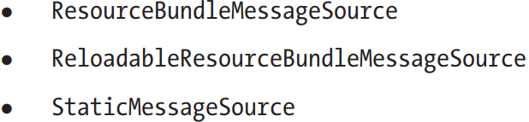

+StaticMessageSource shouldn’t be used in production as you can’t configure it externally.

+ResourceBundleMessageSource loads messages by ResourceBundle.

+ReloadableResourceBundleMessageSource is the same but supports scheduled reloading of source files.

-All 3 of them also implement HierarchicalMessageSource interface for many MessageSource instances to be nested.

-ApplicationContext work with MessageSource instances: define a bean in configuration MessageSource messageSource. ApplicationContext takes this MessageSource and nests it within itself, allow to access messages by ApplicationContext

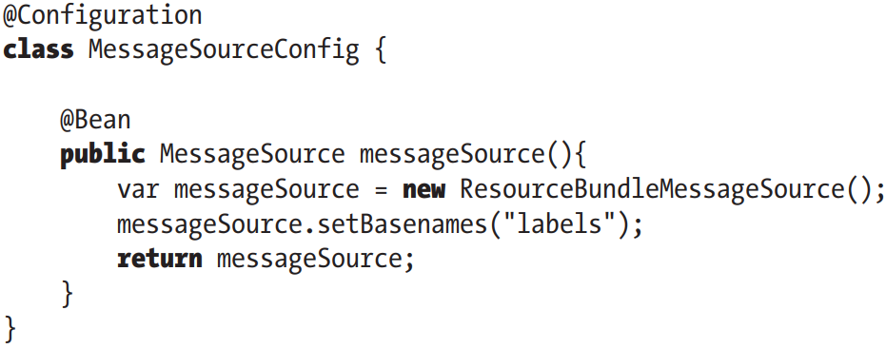

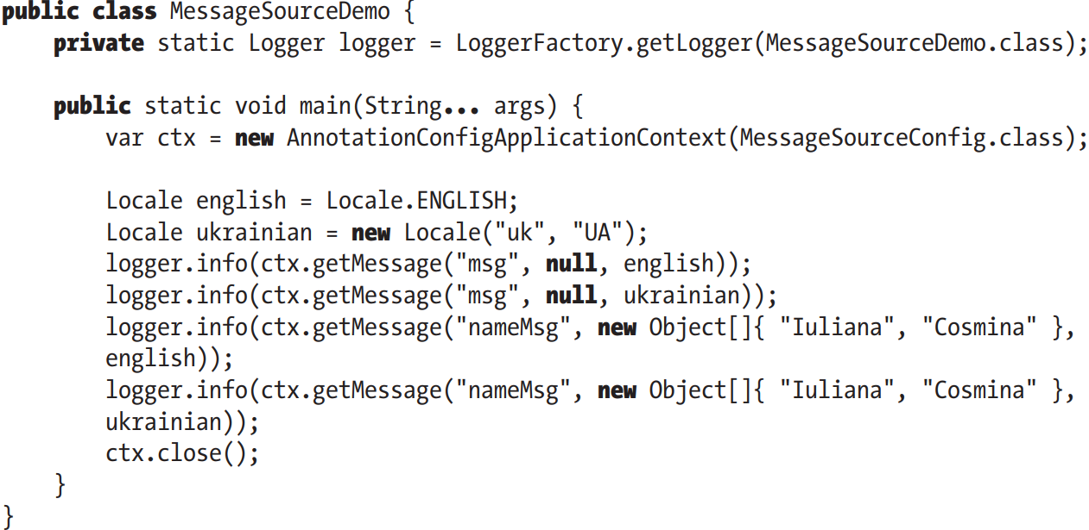

### 4.9.2 Use getMessage()

-MessageSource defines 3 overloads getMessage()

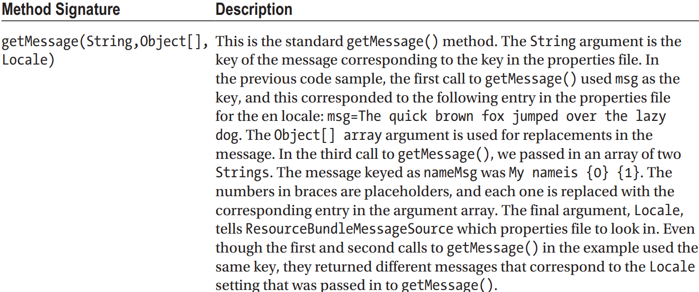

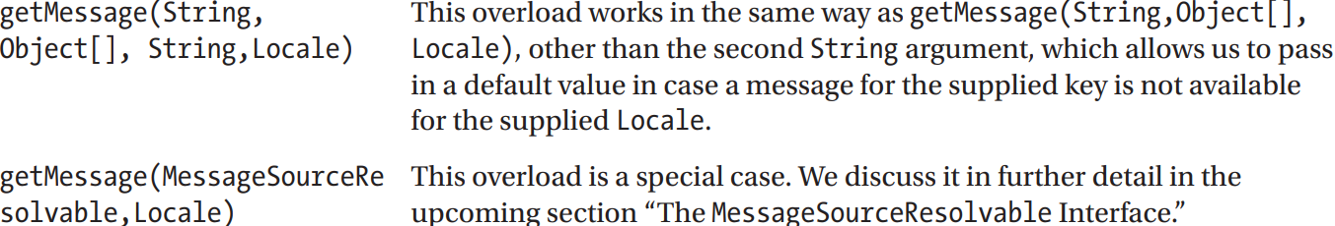

### 4.9.3 Why use ApplicationContext as a MessageSource?

-It’s better to use MessageSource support in ApplicationContext when you build web app.

-(See in book)

### 4.9.4 Use MessageSource in Stand-Alone Applications

-Make MessageSource available by using DI.

-MessageSourceResolvable Interface: place of a key and a set of arguments when looking up a message from MessageSource. This interface is widely used in Spring validation libraries to link Error objects o their internationalized error messages.

### 4.9.5 Events Publication

-Pulish and receive events by using ApplicationContext as a broker.

### 4.9.6 Use Application Events

-event: a class derived from ApplicationEvent, which itself derives from java.util.EventObject. Any bean can listen for events by implement ApplicationListener<T>, ApplicationContext automatically registers any bean that implements this interface as a listener.

-Events are published using ApplicationEventPublisher.publishEvent(), so the publishing class must have knowledge of ApplicationContext (which extends ApplicationEventPublisher).

-In web app, this is simpler because many class are derived from Spring Framework classes that allow access to ApplicationContext through a protected method.

-In a stand-alone app, you can have your publishing bean implement ApplicationContextAware to enable it to publish events.

-A basic event class:

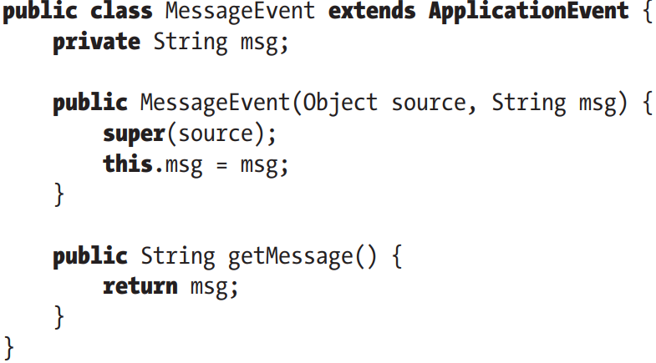

+This constructor accepts a reference to source of event. This is reflected in in constructor for MessageEvent.

-The listener:

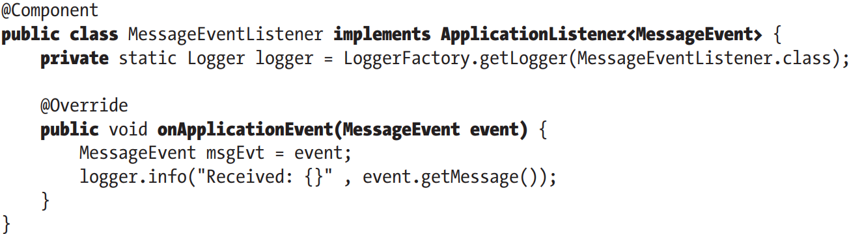

-Publishing events: create an instance of event class and pass it to ApplicationEventPublisher.publishEvent()

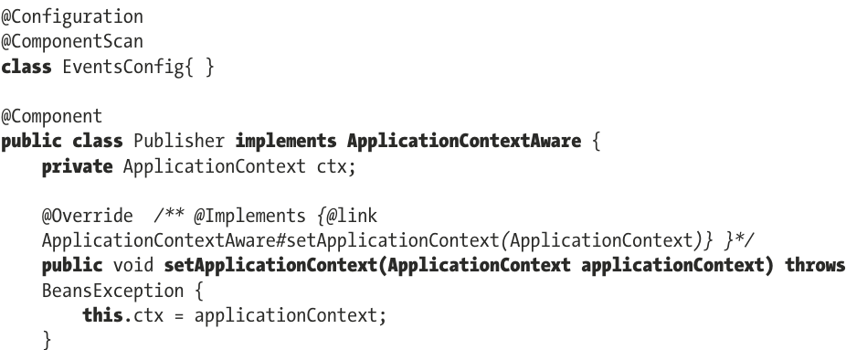

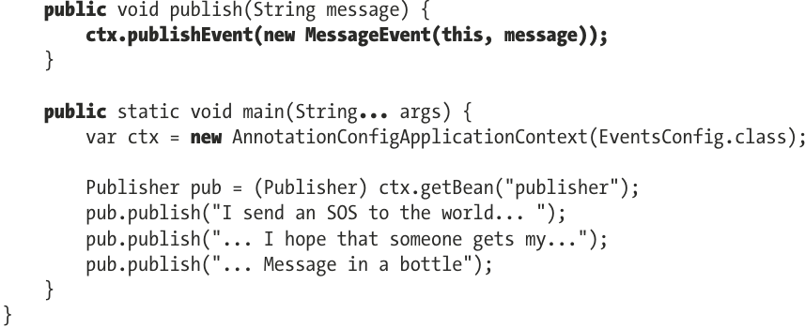

### 4.9.7 Considerations for Event Usage

-In many cases in app, certain components need to be notified of certain events. You do this by writing code to notify each component explicitly or by using a messaging technology (JMS…)

-Typically, we use events for reactionary logic that executes quickly and is not part of main application logic. Messaging systems (JMS, RabbitMQ) for processes that are long-running and form part of main business logic.

## 4.10 Access Resources

-Spring provides a unified mechanism for accessing resources in a protocol-independent way: app can access a file resource in the same way, whether it’s stored in file system, classpath, remote server…

-Spring’s resource: org.spring.framework.core.io.Resource interface

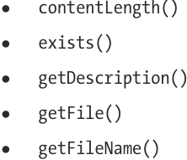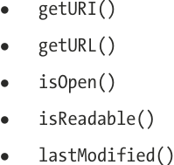

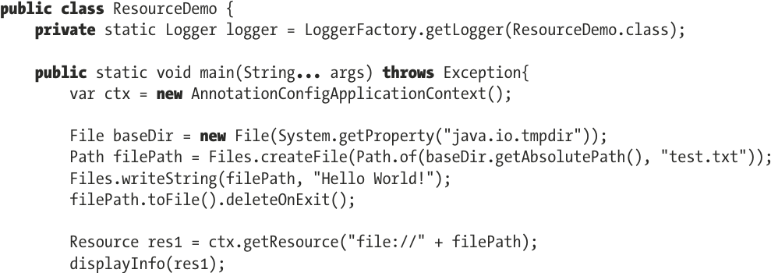

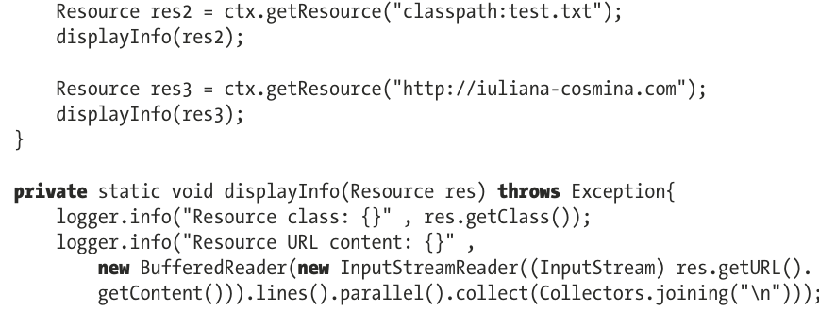

## 4.11 Advanced Java Configuration Classes

-@PropertySource: load properties files and inject them into implementation

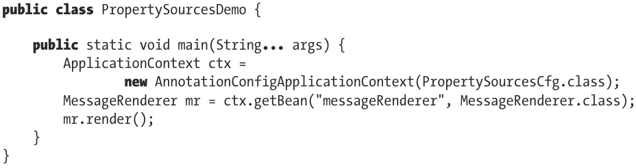

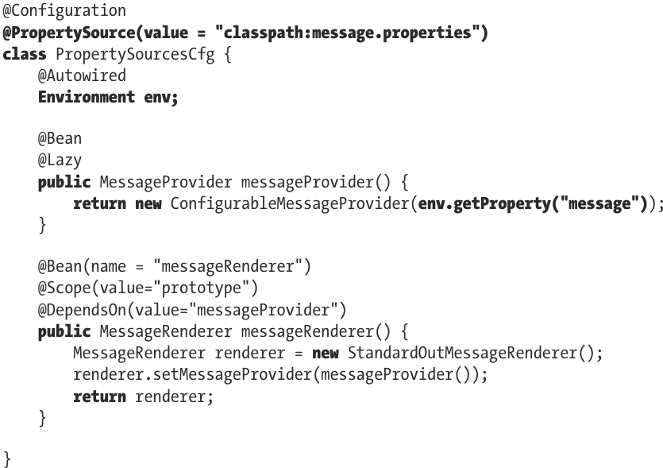

-Some configuration annotations:

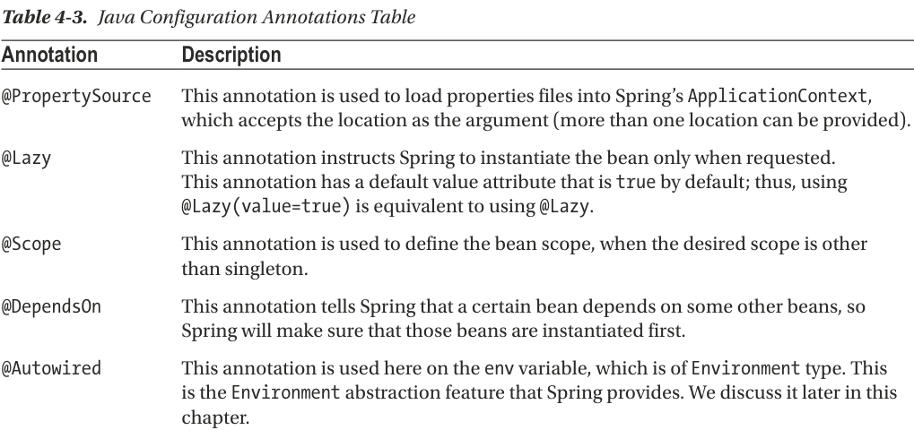

-An application can have multiple configuration classes, which can be used to decouple configuration and organize beans by purpose. Use @Import: import all bean definitions that are declared within or discovered via scanning by the imported class.  
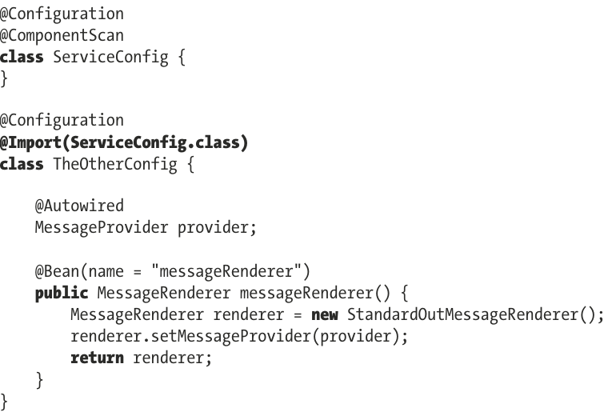

## 4.12 Profiles

### 4.12.1 Example

### 4.12.2 Considerations for Using Profiles

## 4.13 Environment and PropertySource Abstraction

## 4.14 Testing Spring Applications

### 4.14.1 Use Spring Test Annotations

### 4.14.2 Implement Logic Unit Tests

### 4.14.3 Implement an Integration Test

## 4.15 Configure Profile for Integration Testing

### 4.15.1 Implement a Front-End Unit Test

### 4.15.2 Introduce Selenium

## 4.16 Configuration Using Groovy

## 4.17 Use Spring Boot